VOGO eBS  ®  Enterprise Business Suite | DATA SHEET  Module: GIS — Geographic Information System

1. General Overview
The VOGO eBS GIS module is a complete solution for managing, analyzing and visualizing spatial data, natively integrated into the VOGO eBS platform. Based on an open-standard technology stack — GeoServer, OpenLayers and PostGIS — the module provides organizations with enterprise cartography and geospatial analysis capabilities, available both cloud and on-premise.
Industries & Common Applications
The GIS module is most frequently requested in organizations that manage extensive physical infrastructures or processes with an essential geographic component:
▸ Utilities (water, gas, electricity, district heating) — visualization and management of distribution networks, intervention planning, field index readings, faults and repairs
▸ Public Administration & Institutions — urban planning, cadastre, building permits, territory monitoring, zoning plans
▸ Public Health & Veterinary — disease outbreak mapping, monitoring of authorized units, geographic traceability of inspections
▸ Transport & Logistics — route optimization, fleet management, real-time delivery monitoring, warehouse planning
▸ Agriculture & Environment — agricultural plot monitoring, ecological zoning, protected area management, pollution monitoring
▸ Telecommunications — network planning, coverage maps, passive infrastructure management
▸ Emergency & Public Order — intervention coordination, risk mapping, evacuation plans
▸ Retail & Marketing — catchment area analysis, new location selection, customer base mapping
▸ Real Estate & Construction — site due diligence, geographic feasibility studies, project visualization
▸ Ask for more if the industry you are looking for with GIS applications is not found in the list above
2. Technical Architecture & Technology Stack
Main Components
▸ GeoServer — open-source GIS server for publishing, managing and serving geospatial data; support for WMS, WFS, WCS, WMTS; on-premise and cloud deployment
▸ OpenLayers — JavaScript library for interactive map visualization in the browser; support for vector layers, raster, tiles and external services
▸ PostGIS — PostgreSQL extension for efficient storage and querying of spatial data; support for complex geometries, spatial indexing, SQL geospatial analyses
▸ VOGO eBS GIS Integrator – web based and mobile application developed by VOGO Technology based on above technology stack

GeoServer | On-premise & Cloud — WMS/WFS/WCS service publishing, workspace and layer management
OpenLayers | Interactive web viewer — zoom, pan, layers, drawing, attribute editing directly on the map
PostGIS | Spatial storage — geometries, R-Tree indexing, SQL geospatial analyses, time-series data
Deployment | On-premise (own server) or Cloud (AWS, Azure, GCP) — flexible architecture
Supported Formats | SHP, KML, GeoJSON, CSV with coordinates, GPX, GeoTIFF, DWG, DXF, external WMS/WFS

3. Visualization & GIS Viewer Interface
The platform provides a complete GIS Viewer, accessible from the web interface, with full functionality for interacting with geospatial data.
▸ Enables visualization and interaction with vector and raster maps with full zoom, pan and navigation functionality
▸ Displays network element attributes directly on the map upon selection, without additional navigation
▸ Allows adding, hiding, reordering and deleting geographic data layers
▸ Organizes layers hierarchically (tree structure), with full visibility and transparency control
▸ Provides direct drawing tools on the map: points, lines, polygons for marking areas of interest
▸ Includes an accessible control panel for managing all functions: layers, visualization, analysis
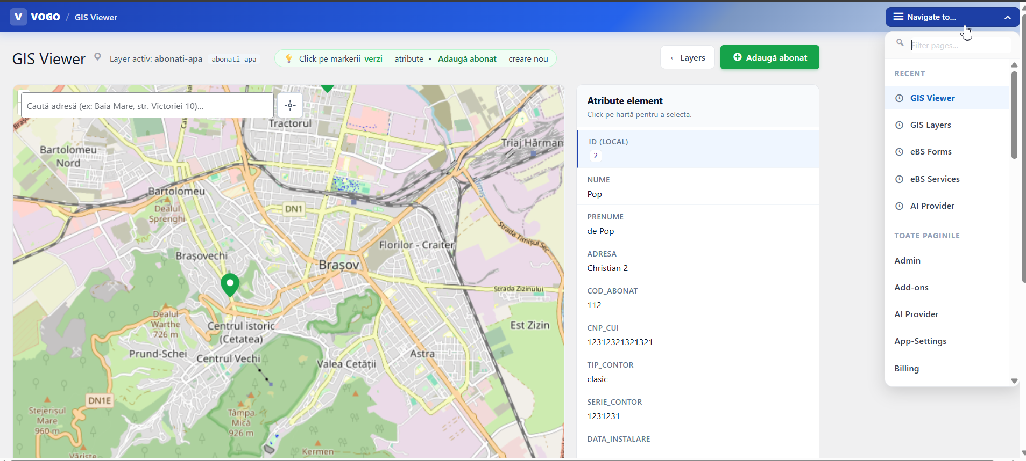
Fig. GIS Viewer VOGO eBS: map view, active layers and selected element attributes
4. Layer Management & GeoServer Configuration
The platform provides a complete administrative interface for defining and managing GIS layers, natively connected to GeoServer.
▸ Allows creation of layers with unique code, display name and description, organized hierarchically (parent-child structure) with configurable sort order
▸ Defines the layer type and how data is obtained from GeoServer, controlling what actions the user can perform
▸ Allows modification of network element attributes directly from the viewer, with automatic propagation to GeoServer
▸ Ensures real-time synchronization of changes between the web interface and the GIS server
▸ Supports overlay with external geospatial data: cadastral data, street nomenclature, topographic maps

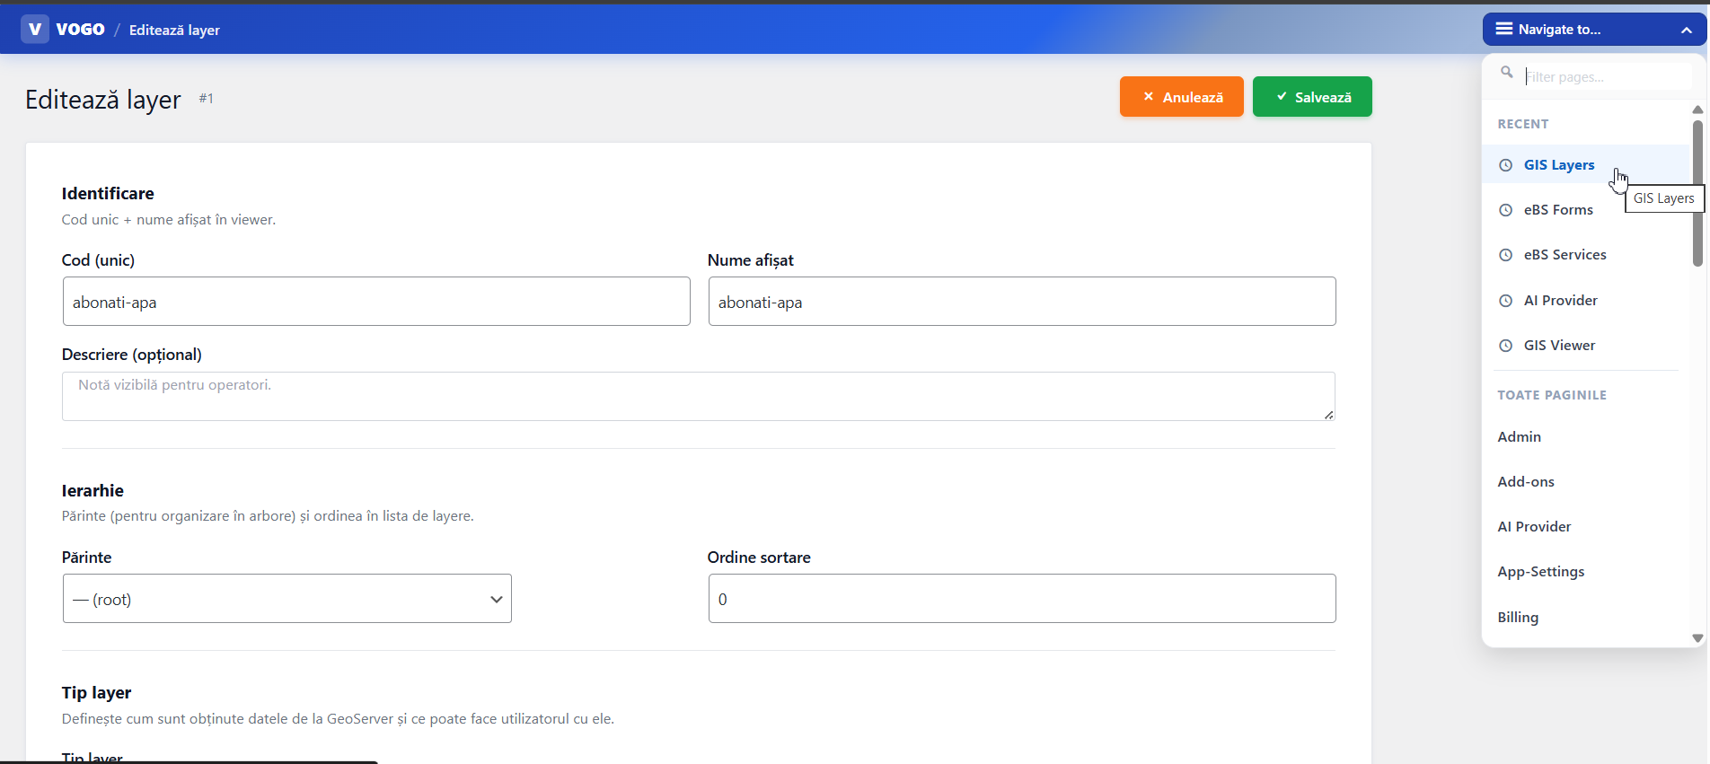
Fig. GIS layer definition and editing interface with native GeoServer integration

5. Integration with VOGO Portal & Forms
The GIS module is natively integrated with VOGO Portal and VOGO Forms, enabling the use of interactive maps directly in digital forms and public services.
▸ Provides a dedicated 'Map' field type in the form builder, integrable in any digital form without code
▸ Allows citizens to locate addresses on the map directly from the request form, with 'Locate my current position' functionality
▸ Supports address fields with automatic geocoding (text address → geographic coordinates transformation)
▸ Integrates the map into public service workflows: authorizations, approvals, requests — with geographic positioning of the request
▸ Allows generation of approvals with placement of the graphic symbol at the exact location on the map and attachment of the complete electronic file

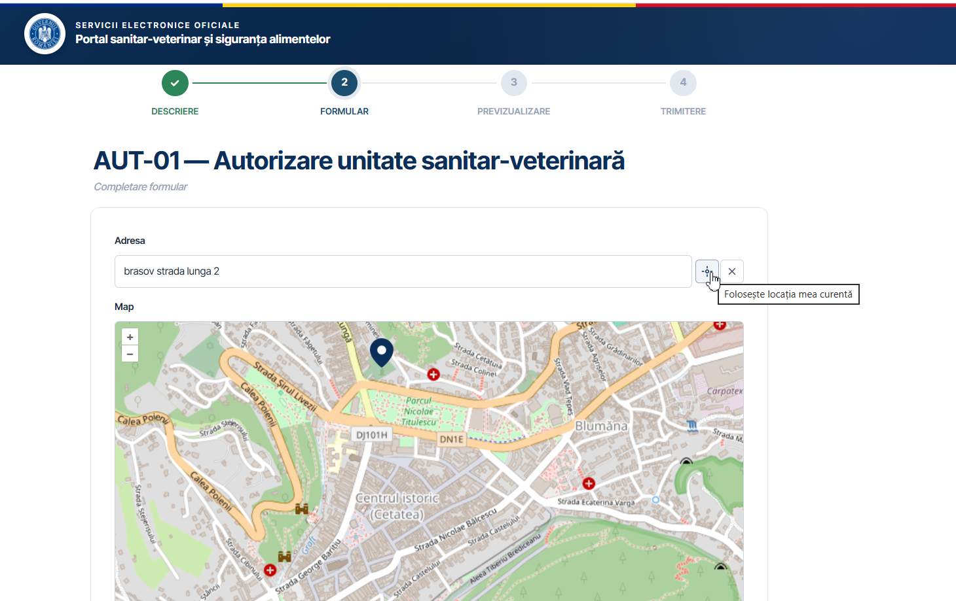
Fig. GIS integration in Public Portal: authorization form with interactive map field

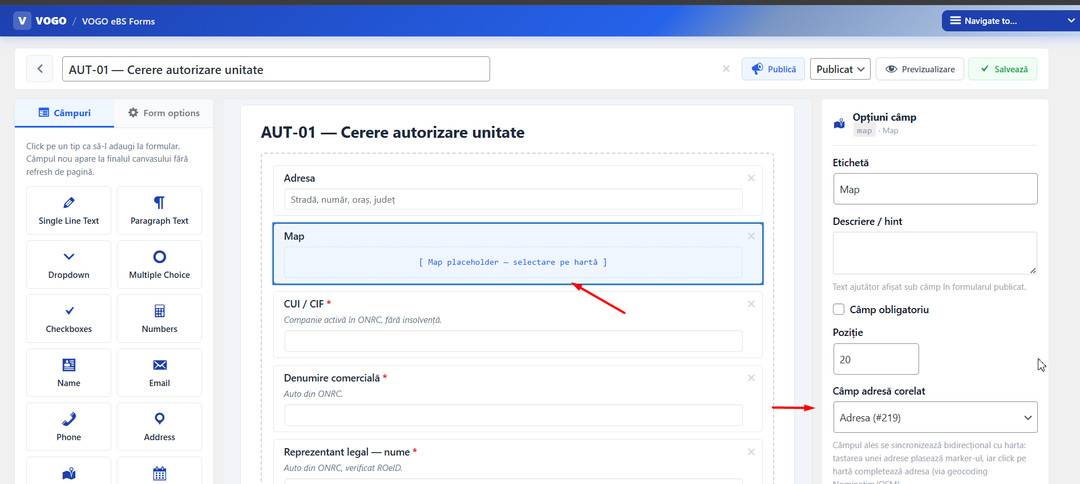
Fig. Map field available in the VOGO eBS Forms form builder
6. Spatial Analysis & Geocoding
▸ Performs complex spatial analyses: intersections, buffer, proximity analysis, area and distance calculation
▸ Includes geocoding functionality for transforming addresses and textual descriptions into geographic coordinates (latitude/longitude)
▸ Supports management and visualization of geographic data by time intervals (time-series data), facilitating temporal analysis
▸ Allows filtering and querying of spatial data via geospatial SQL (PostGIS) for reports and complex analyses
▸ Generates reports with map visualization of the selection: pie chart, bar charts with drill-down to individual elements on the map
7. Mobile Application for Field Interventions
▸ Visualizes customers and network elements on the map directly from the Android/iOS mobile device
▸ Allows reading the index and transmitting it in real time to the management application
▸ Works offline with local data saving when the device is disconnected from the internet, with automatic synchronization upon reconnection
▸ Allows generation of intervention reports with configurable fields: dropdowns with auto-filtering nomenclatures, classic fields, dates
▸ Supports handwritten signature directly on the mobile device screen
▸ Automatically generates and sends the signed PDF file by e-mail
8. Additional Features
Data Import & Export
▸ Supports data import and export in standard geographic formats: SHP, KML, GeoJSON, CSV with geographic coordinates, GPX
▸ Allows loading and visualization of data from external sources, ensuring compatibility with geospatial data standards
▸ Allows attaching complete electronic files to geographic elements: PDF, JPG, DWG, DXF and other formats
Public Citizen Portal
▸ Generates public portal sections available to citizens at a public web address with login, visualization and data submission functionality
▸ Allows bill payment by card directly from the platform, with automatic confirmation and debt clearance
Dashboard & BI
▸ Provides a dynamic dashboard with filters by information types: readings, interventions, pie chart and bar graph visualization
▸ Allows detailed map display of elements selected from reports, with the ability to work on each element and export data
▸ Natively integrates with the platform's BI solution for maps, DMS and mobile applications
User Interface
▸ Provides a user-friendly and intuitive interface, easy to use for both technical and non-technical users
▸ Allows differentiated interaction modes for internal users and citizens/external users
9. Performance, Security & Scalability
▸ Efficiently manages large volumes of geographic data with fast response times and smooth user experience
▸ Includes user authentication and authorization, data encryption and complete access auditing
▸ Allows subsequent addition of new features and modules to adapt to the changing needs of the organization
▸ Is scalable to handle an increasing number of users and larger data volumes as the organization grows
▸ Uses open standards and protocols (OGC: WMS, WFS, WCS) for interoperability with any external system
10. Supported Integrations
VOGO Forms | Native Map field in the form builder — geocoding and location in digital workflows
VOGO Portal | Interactive maps in the public portal for citizens and authorization services
VOGO BI | Dynamic dashboards with geospatial visualization, filters and data export
DMS | Attaching electronic files (PDF, DWG, DXF, JPG) to geographic elements
Mobile Application | Network visualization, index readings, field interventions, offline sync, handwritten signature
External GIS Server | Consumption of GIS services published by third-party systems via standard WMS/WFS
Payment System | Bill payment by card directly from the public portal component
Invoicing System | Invoice visualization and their status; Customer file;

