VOGO eBS  ®  Enterprise Business Suite | TECHNICAL SPECIFICATION SHEET  VOGO eBS for eAdministration

1. Overview
VOGO ® eBS for eAdministration is the integratedă, AI-powered eAdministration suite that digitalizes the relationship between public institutions, citizens, businesses, and authorized professionals. The platform provides a modern Public Services Portal — a single gateway to digital services — complemented by an intelligent form engine (Forms), configurable services (Services), conversational AI assistance, and native mobile applications, all integrated into a secure, scalable ecosystem compliant with European standards.

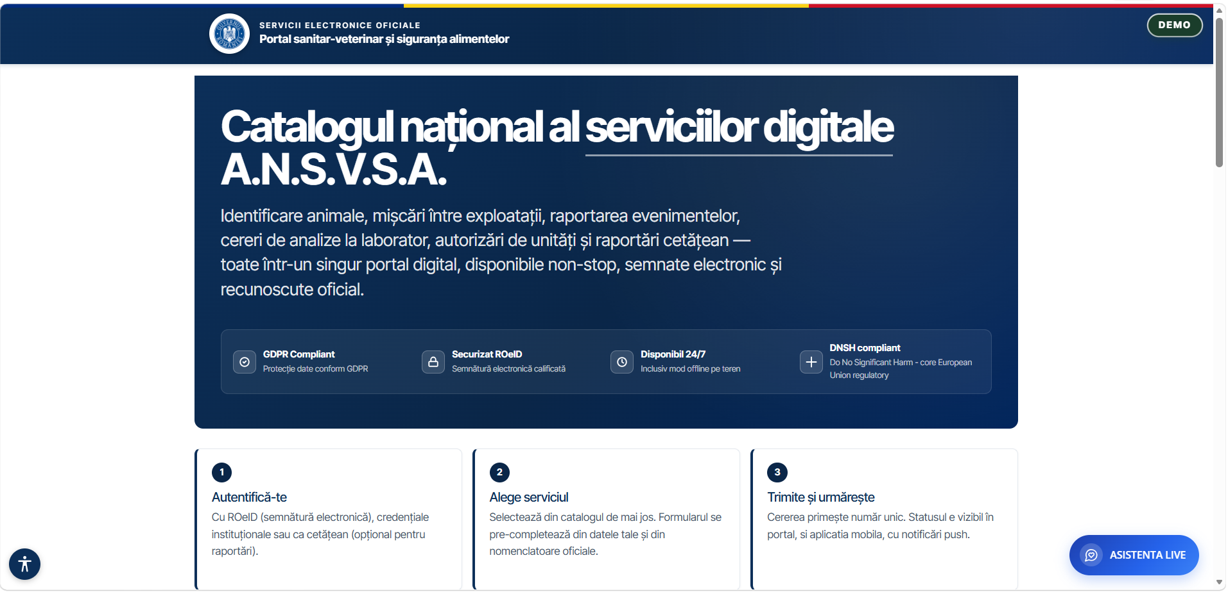
Fig. 1 — Example national digital services portal: homepage with service catalog, ROeID authentication, and live AI assistant
2. Public Services Portal
Unified Access & Service Catalog
The portal serves as the single gateway for citizens, businesses, and authorized professionals to all digital public services of the institution.
▸ Provides a complete catalog of digital services, organized by category, with description, deadlines, costs, and required documents for each service
▸ Allows access to any public service through a 4-step wizard flow: Description → Form → Preview → Submit
▸ Accessible from any internet-connected device — computer, tablet, mobile phone — with fully responsive design, automatically adapted to screen sizes
▸ Provides multi-language capabilities for users from different linguistic contexts
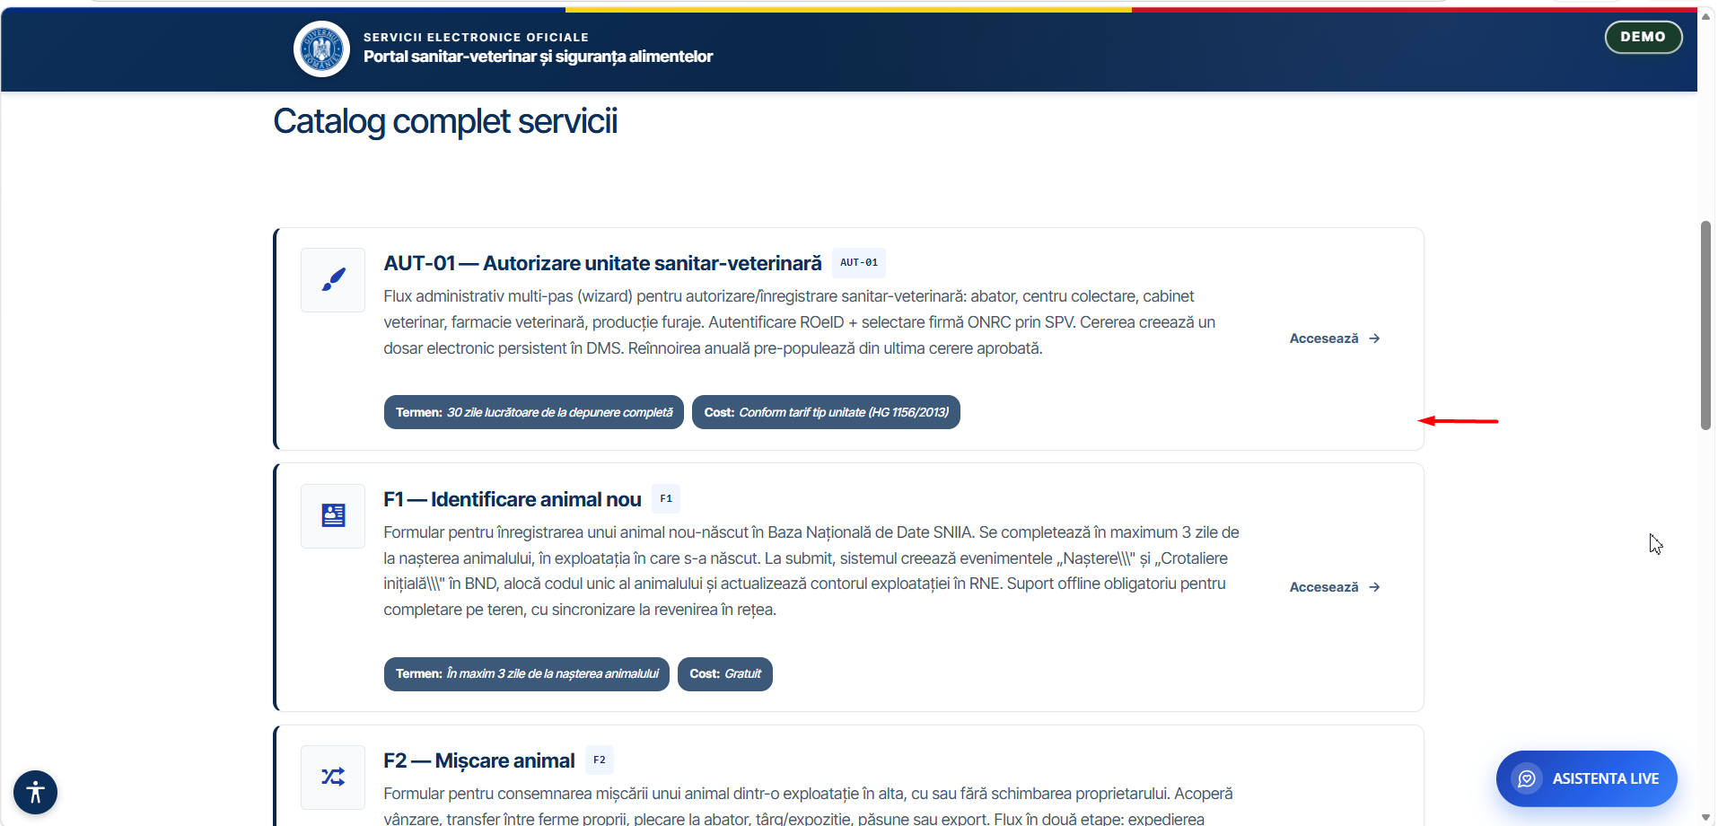
Fig. 2 — Complete service catalog: AUT-01, F1, F2 with deadlines, costs, and publication status
Authentication & Digital Identity
▸ Integrates with ROeID for digital identification of natural persons, with automatic pre-population of ROeID profile data into forms
▸ Integrates with eIDAS for recognition of electronic identity at European level
▸ Integrates with ONRC for automatic retrieval of company data (name, tax ID, legal representative) via SPV selection
▸ Implements differentiated accounts by profile: citizen, veterinary doctor, commercial company — with functionalities and information specific to each profile
▸ Allows authentication via username and password or anonymous access, with possibility to upgrade to a verified ROeID account
Complete Digital Flow — from Request to Confirmation
▸ Guides the user through an intuitive multi-step wizard with visual progress indicator
▸ Automatically pre-populates form fields with data from ROeID and ONRC, eliminating redundant manual entry
▸ Allows attaching required documents directly from the browser, with file type and size validation
▸ Includes an integrated GIS map field for geographic location of requests (coordinates auto-filled on map click)

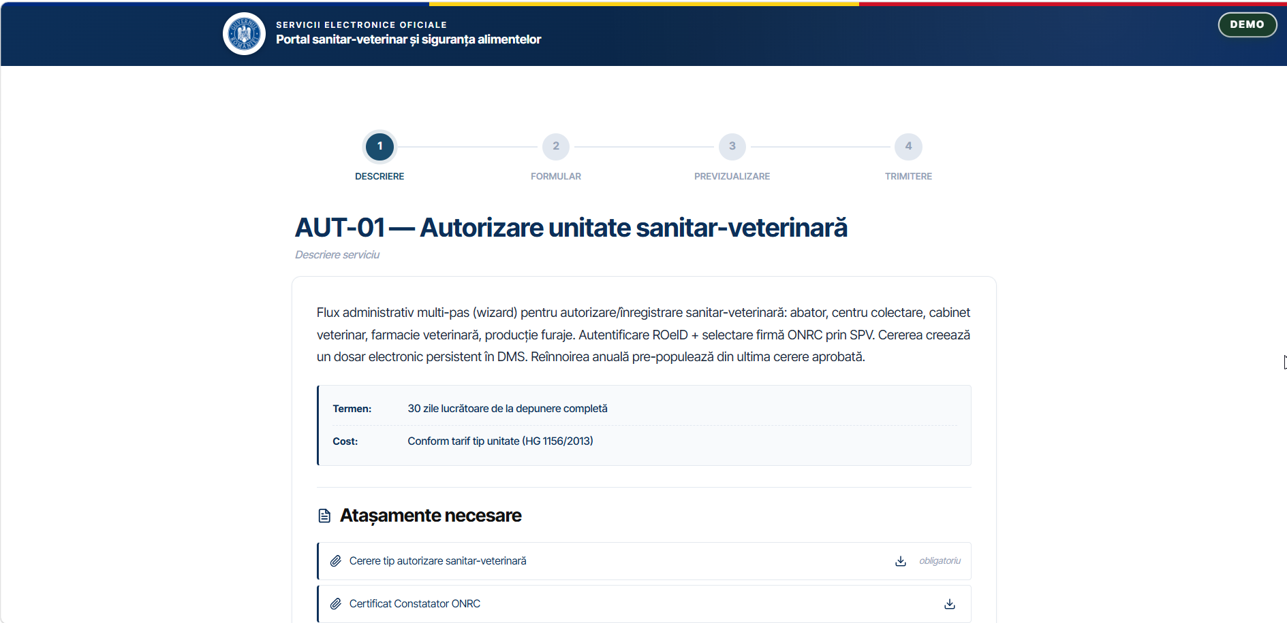
Fig. 3 — Step 1/4: AUT-01 service description with wizard flow, deadlines, and required attachments

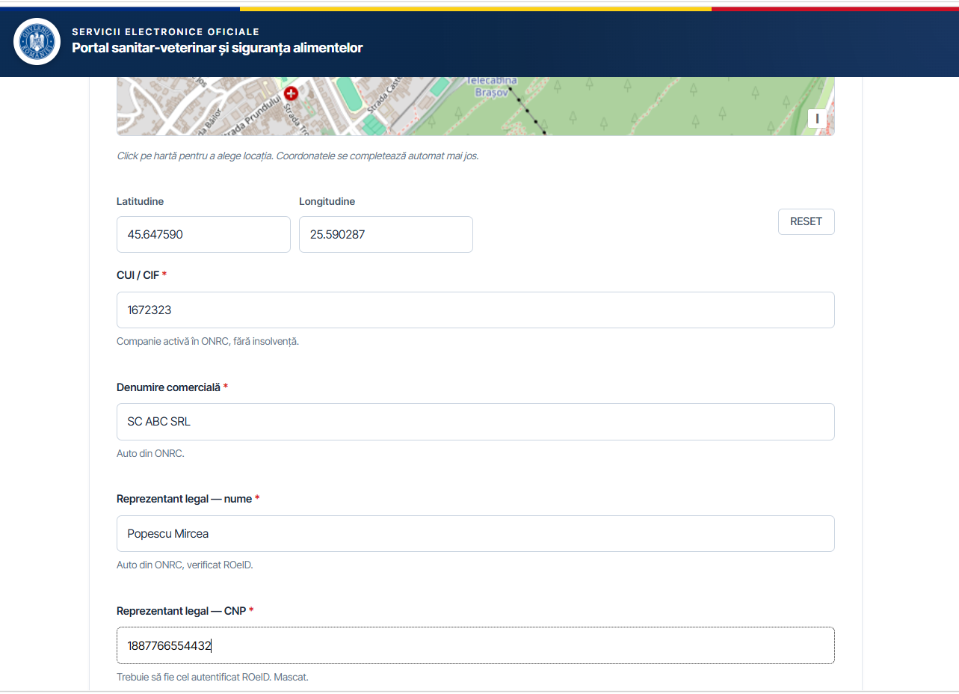
Fig. 4 — Step 2/4: Form completion with GIS map, CUI/CIF auto-filled from ONRC and ROeID data
Digital Handwritten Signature & Finalization
▸ Includes a digital handwritten signature module directly in the browser, with mouse or finger on touch screen
▸ Allows full preview of the completed and signed form before submission
▸ Automatically generates the PDF of the signed request, available for download or email delivery
▸ Confirms submission with a registration number and allows tracking of the request status

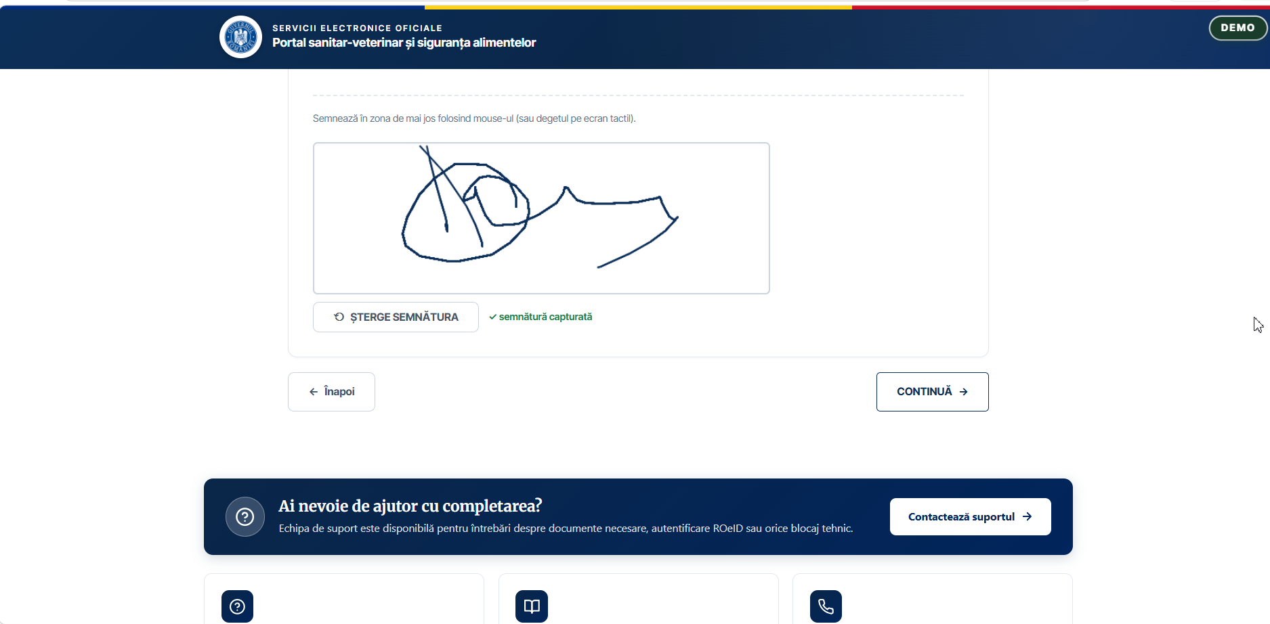
Fig. 5 — Digital handwritten signature: captured directly in browser with mouse or touch screen
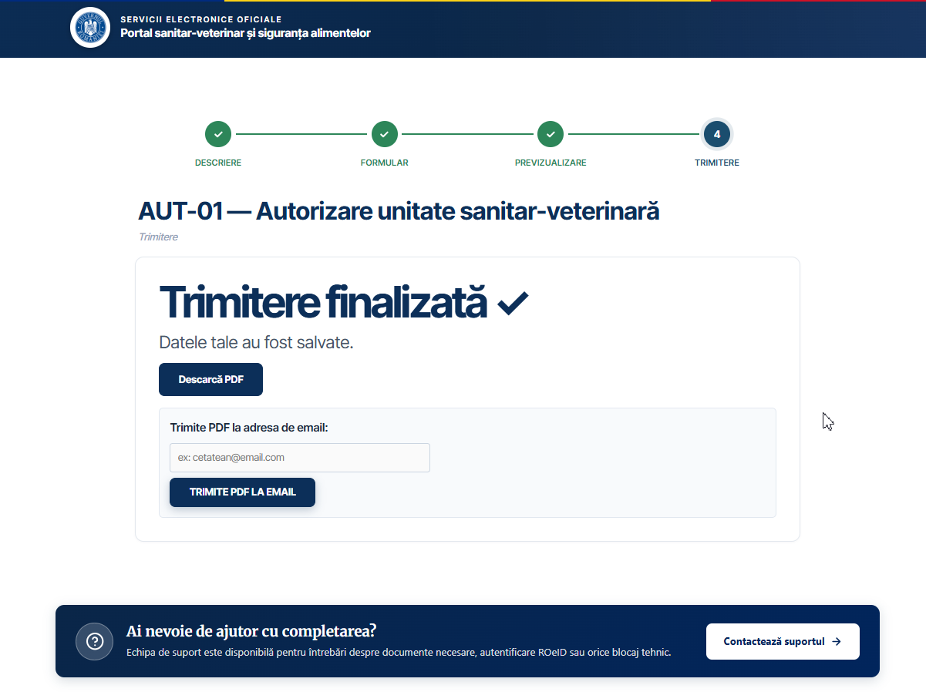
Fig. 6 — Step 4/4: Submission finalized — PDF download and email delivery
3. WCAG Accessibility & Live AI Assistant
The platform complies with the WCAG standard for web accessibility and includes a conversational AI assistant permanently available to users.
▸ Complies with the Charter of Fundamental Rights of the European Union and Art. 9 of the UN Convention on the Rights of Persons with Disabilities
▸ Provides a comprehensive accessibility options panel: text zoom in/out, high contrast, dark mode, greyscale, readable font, underline links, large cursor, stop animations
▸ Supports screen reading, keyboard-only navigation, and adjustable contrast
▸ Includes the Live AI Assistant available in the page corner, active 24/7, ready to guide the user in completing any service
▸ The AI Assistant operates in Human-in-the-Loop (HITL) mode: it can transfer the conversation to a human operator when the situation requires it
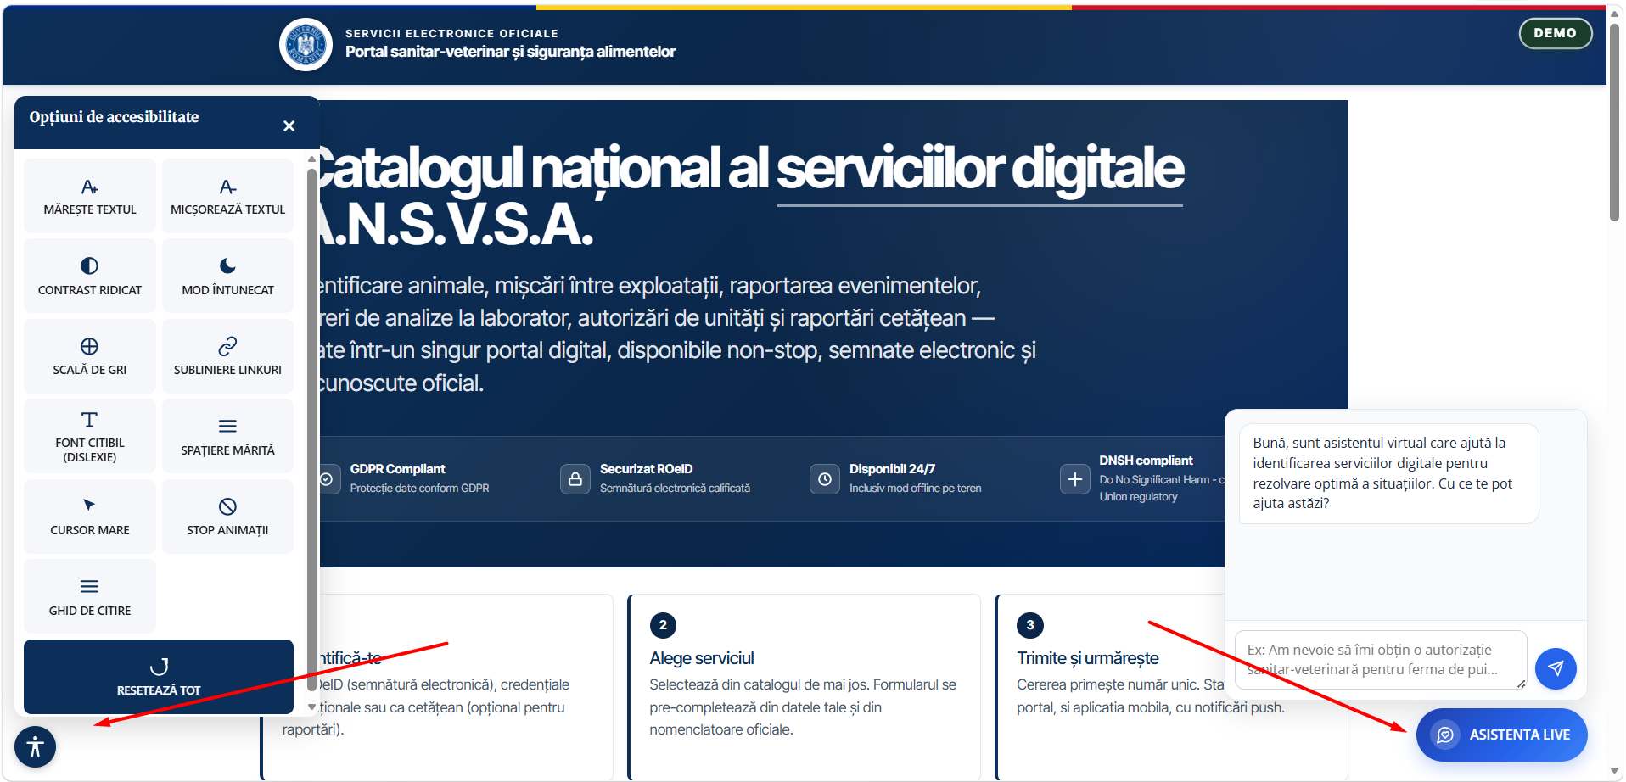
Fig. 7 — WCAG accessibility panel and active Live AI Assistant (HITL)
4. Administration & Backend — VOGO eBS Services
The platform provides administrators with a comprehensive backend for creating, configuring, and publishing digital services.
▸ Allows creating services from predefined templates or from scratch, without writing code
▸ Configures deadlines, costs, required documents, form templates, and approval flows per service
▸ Manages the status of each service: Draft → Published, with granular visibility control
▸ Provides platform performance monitoring tools, traffic and usage reports
▸ Allows management of user accounts, permissions, and access profiles
▸ Includes a Content Management System (CMS) for rapid updating of public information without technical intervention

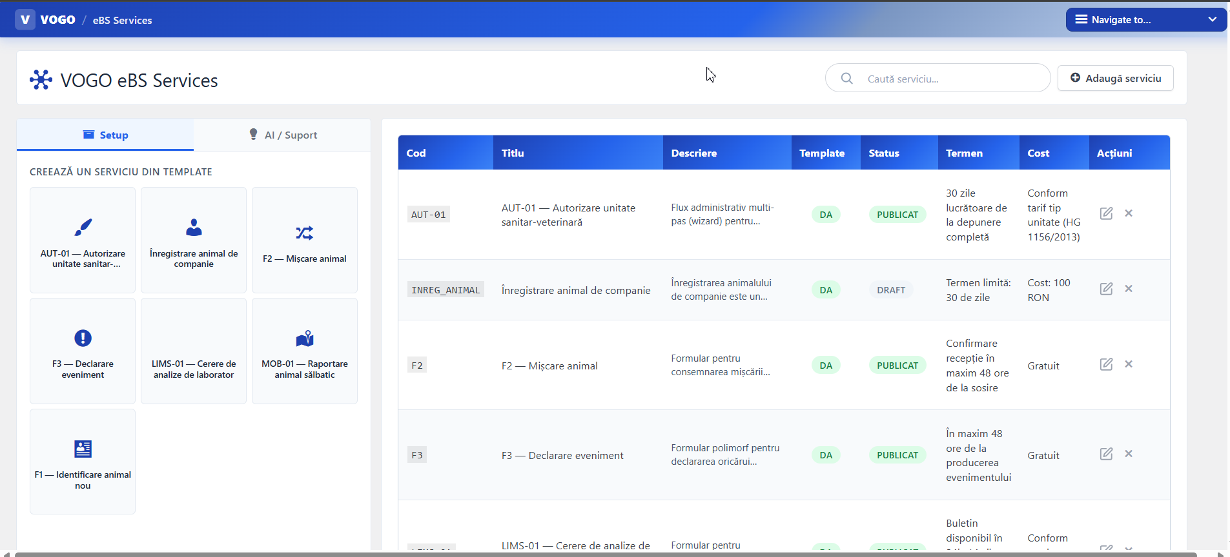
Fig. 8 — VOGO eBS Services backend: service management, templates, status, and configuration
5. Mobile Application — VOGO MAF (Mobile Application Framework)
VOGO eBS Gov Series™ includes native iOS and Android mobile applications for citizens, connected to the same portal ecosystem.
▸ Allows access to all relevant public services from the portal directly from the mobile device  ▸ Fully responsive design, automatically adapted to the screen sizes of phones and tablets  ▸ Allows offline work: data entry and events saved locally on the device, with automatic synchronization upon reconnection  ▸ Sends push notifications to the citizen on any change or progress of their requests  ▸ Ensures communication exclusively over secure channels (SSL/TLS) between terminal and servers  ▸ Allows farmer authentication via 3 data points: farm code, last digits of personal ID, animal tag from registry  ▸ Allows consultation of the up-to-date farm registry, including in offline mode  ▸ Supports digital handwritten signature directly on the touch screen of the mobile device  ▸ Generates and sends signed PDFs directly to email from the application | 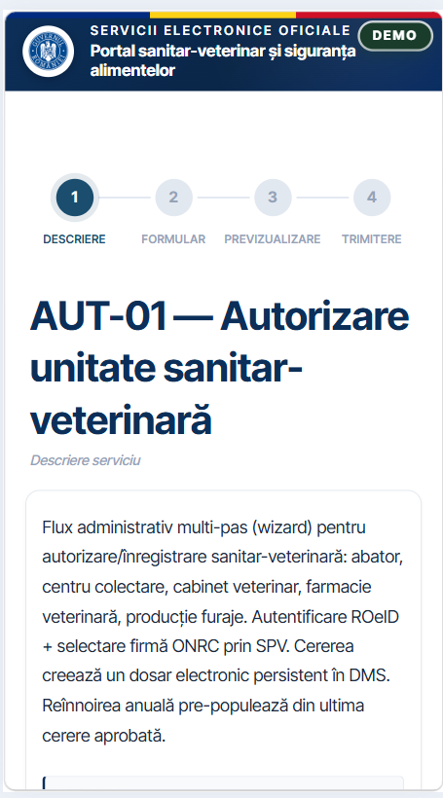  Responsive design — mobile view
6. Security & GDPR Compliance
▸ Implements robust authentication and authorization with differentiated profiles: citizen, authorized professional, commercial company
▸ Encrypts all communications between user and servers via SSL/TLS
▸ Stores personal and commercial data securely, with periodic audits and advanced monitoring mechanisms
▸ Fully complies with GDPR requirements for the protection of personal data
▸ Ensures a complete audit log of all actions on the platform
▸ Integrates ROeID and eIDAS for verified digital identification at national and European level
7. Supported Integrations
ROeID | Digital identification of natural persons, pre-population of form data, masked personal ID
eIDAS | Recognition of electronic identity at European level
ONRC / SPV | Automatic retrieval of company data: name, tax ID, legal representative
GIS Module | Interactive map field in forms, address geocoding, request location
DMS | Persistent electronic file per applicant, visible in all platform modules
AI Chatbot | Live 24/7 assistant, HITL, form completion guidance, multi-channel support
Email / SMS | Automatic request status notifications, signed PDF delivery, confirmations
Payment System | Payment of fees and tariffs associated with services directly from the portal

Industries & Common Applications

The eAdministration module is most frequently requested in organizations that manage an intensive relationship with citizens and the business environment — where there is a large volume of repetitive interactions, standardizable forms, and digitalization pressure from European directives:

▸ Local & Central Public Administration; Municipalities, county councils, prefectures — issuance of building permits, urban planning certificates, event registration, public information requests, online payment of local taxes and fees, etc.
▸ Public & Veterinary Health; authorization of units, hospitals, doctors, appointments, reporting, official inspections and controls, document issuance, traceability, elements related to public health.
▸ Agriculture & Environment; subsidy applications, agricultural land declarations, environmental reports, environmental permits, farm monitoring, management of the farmer registry.
▸ Education; School inspectorates, universities — online enrollment, scholarship applications, diploma recognition, statistical reports, communication with parents and students, management of academic documents.
▸ Human Health; County health insurance funds, public hospitals — online appointments, reimbursement requests, registration of healthcare providers, contractual reporting with the Health Insurance Fund.
▸ Public Utilities & Infrastructure; Water, heating, and sanitation operators — connection requests, fault reports, online meter readings, bill payments, service interruption notifications, public citizen portal.
▸ Public Order & Safety; Local police, emergency services, civil protection — event permit applications, incident reporting, authorization requests for high-risk activities, management of intervention files.
▸ National Registers & Professional Licensing; Professional orders (doctors, lawyers, architects, pharmacists) — member registration, authorization renewal, CPD reporting, member communication, publication of public registers.
▸ Transport & Public Logistics; road authorities, port/airport authorities, public bodies — transport authorizations, technical inspections, operator licenses, incident reporting, vehicle conformity certificates.
▸ Ask for more if your industry is not listed above

