VOGO eBS  ®  Enterprise Business Suite | DATASHEET  VOGO MAF — Mobile App Framework  The AI Mobile Application Framework — Native iOS + Android




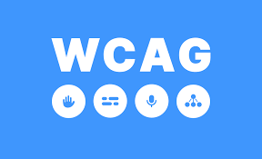


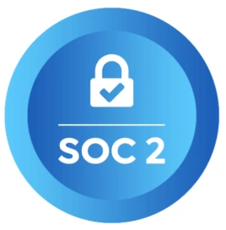
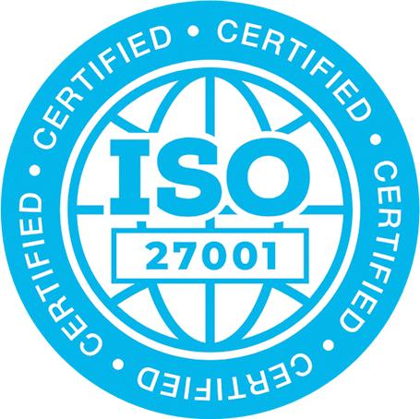



1. Overview – VOGO® MAF (Mobile Application Framework)
VOGO® MAF (Mobile Application Framework) is the framework through which any organization rapidly builds a native iOS and Android mobile app, under its own brand, publishable in the Apple App Store and Google Play. The framework drastically reduces the implementation time of a mobile app — from months to weeks — and removes the need for a complex mobile developer team. The framework enables the rapid build of a native mobile app for the organization, with custom branding (logo, colors, tailored screens), multi-language options, and connection to any backend via REST API. The app can run standalone or as a mobile extension of an existing online store (multi-language and multi-territory), published in both the Apple App Store and Google Play (under the customer's own brand)

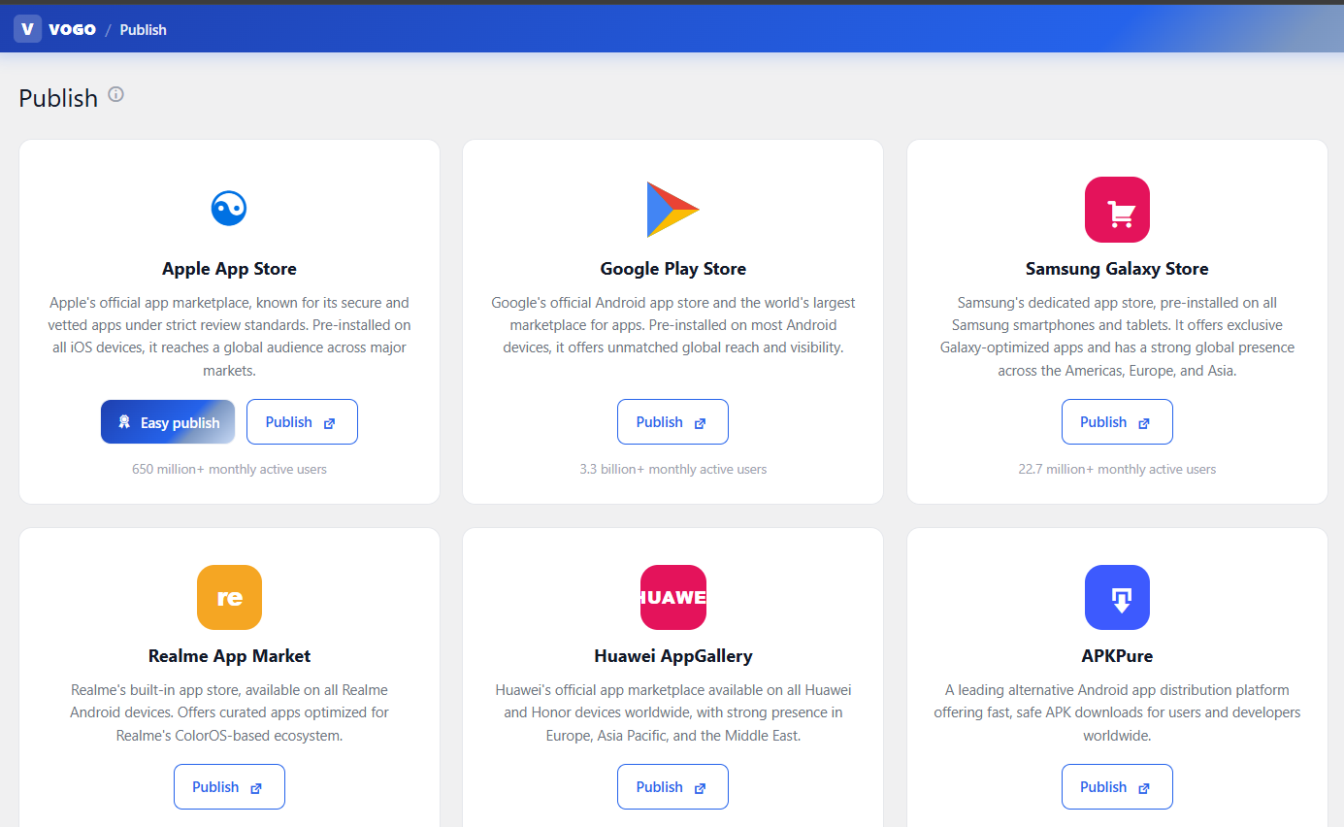
Fig. — The VOGO® MAF — Mobile App Framework - Mobile app publisher assistant
The mobile app delivers complete functionality for any scenario: catalog of products or services, cart and checkout with online payments (Stripe, Netopia), order management, user profile, GPS maps, live chat, video calls, digital handwritten signature, and offline mode.
The app is configured from a web panel — Brand Control Center — with no Flutter, Android, or iOS knowledge required. 8 tabs allow customization of every app screen (Splash, Welcome, Login, Bottom bar, Home, Menu, Settings, Theme), and additional modules cover push notifications, chat, AI Provider, categories, user roles, and a store-publishing assistant. VOGO® MAF natively integrates a 24/7 conversational AI assistant, trained on the customer's catalog, FAQs, and policies. The assistant runs directly inside the app, delivering personalized recommendations, customer scoring, fraud detection, and guidance for completing orders or forms — all with Human-in-the-Loop (HITL) support for handoff to a human operator when needed.
The framework includes an App Publisher Assistant for generating and publishing the app in the Apple App Store and Google Play, with automatic APK / AAB generation for Android and IPA for iOS. Plus an Auto Install & Self-Check system that automatically diagnoses the integration and suggests fixes. For backend details, see the VOGO® eBS eCommerce DataSheet. For AI details, see the VOGO® eBS AI DataSheet.

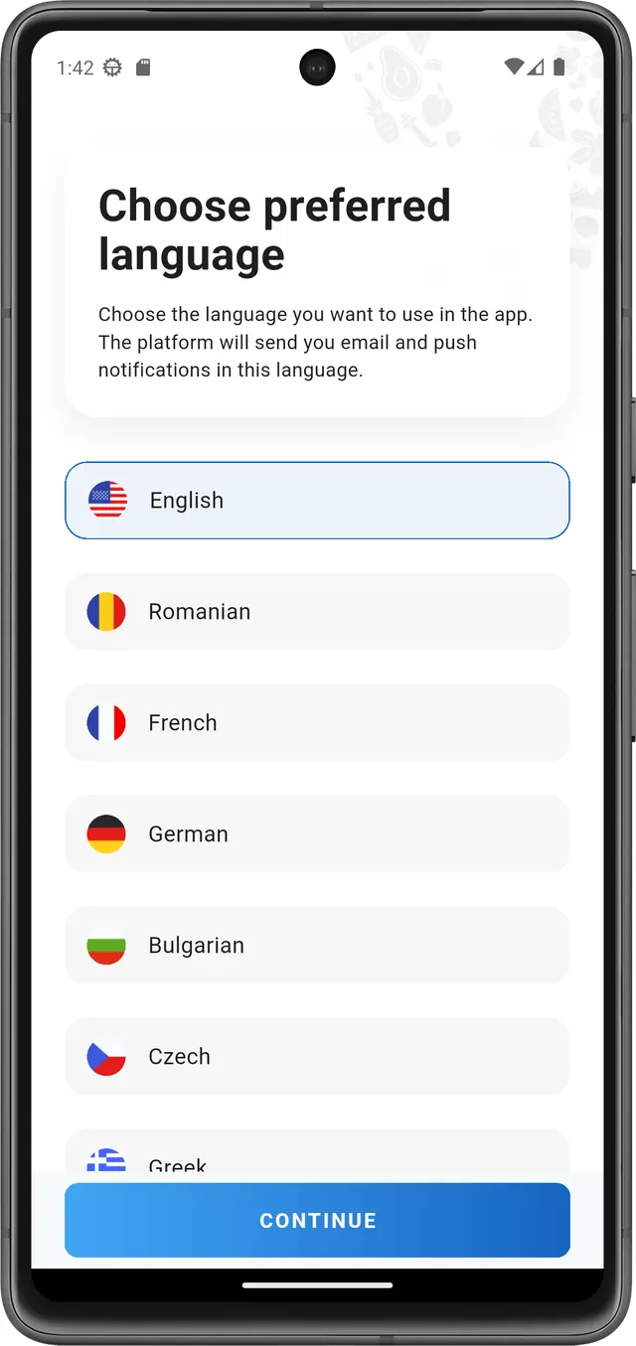  Multi-language | 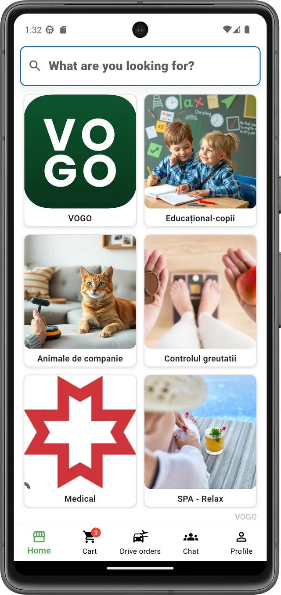  App configuration | 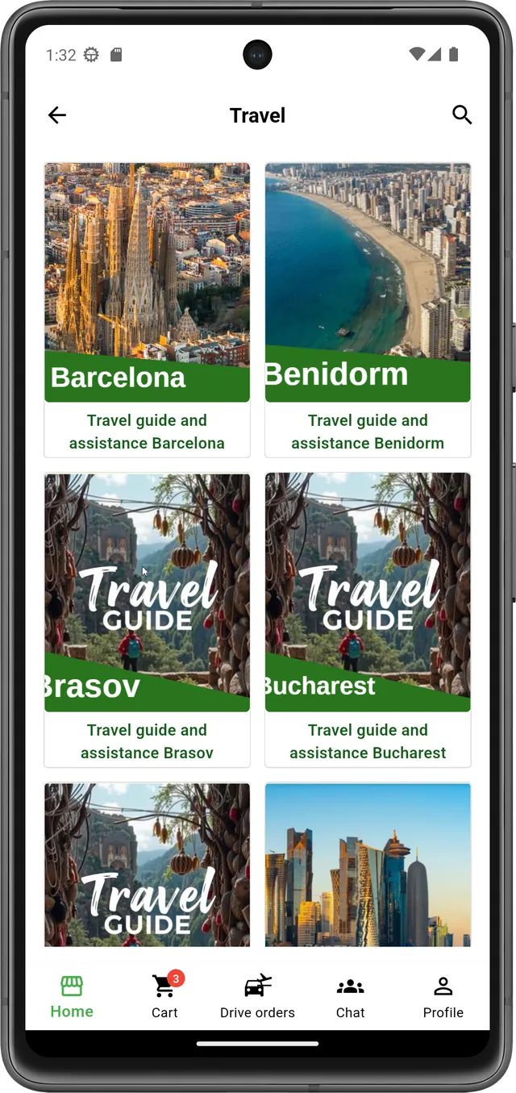  Brand Control | 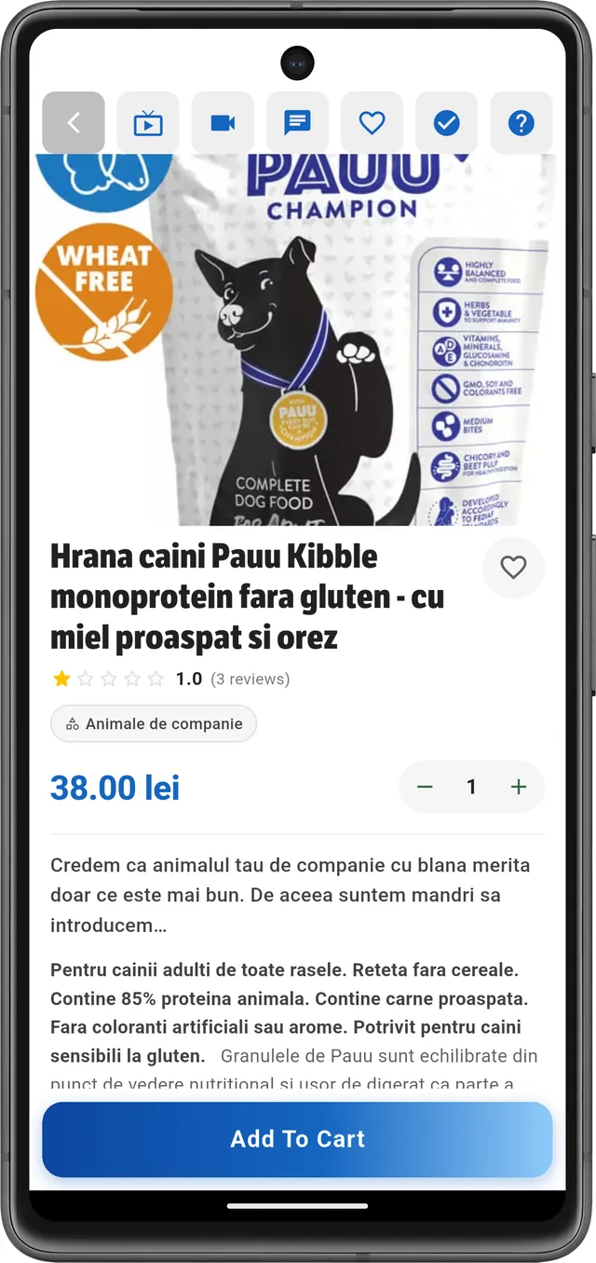  REST endpoints

Beyond classic scenarios, VOGO® MAF enables the rapid build of mobile apps for online services, digital forms, ticketing, loyalty, transport, and eGov. The framework is built to cover any domain with a single Flutter codebase or React Native / Xcode code, allowing organizations to launch and operate native mobile apps under their own brand, without investing in in-house development.
Thanks to its three-layer architecture (Mobile App + Brand Control Center + REST API with 200+ endpoints), VOGO® MAF reduces mobile app implementation time from months to weeks, standardizes delivery, and provides organizations with a mature technology foundation for any mobile scenario.

2. What VOGO® MAF solves for you?
1 I need ... App A mobile app connected to my existing store — Shopify, Woo, Presta, Magento, or any REST API / XML / Feed

What you get from VOGO® MAF:
Native iOS + Android app on top of your existing store
- Native app publishable in the Apple App Store and Google Play under your own brand
- Connects to Shopify, WooCommerce, PrestaShop, Magento, or any REST API backend
- Integrable with OpenAI, Anthropic Claude, Groq, Gemini — the provider of your choice
- Cart, checkout, Stripe SDK + Netopia + Apple/Google Pay payments, PDF invoicing
- Firebase push notifications for promotions and order status
- Web Brand Control Center for customizing logo, colors, and screens — no code required
- Modern 24/7 AI & HITL assistant for customer interaction in-app, optimized with RAG, Ollama, LangChain, and LangGraph — running on open-source models or integrated with OpenAI, Anthropic Claude, Groq, or Gemini.

2 I need ... A mobile app for services and bookings

What you get from VOGO® MAF:
App for clinics, practices, agencies, consultants
- All features from scenario 1, plus:
- Service catalog organized by category, with a detailed page per service
- Booking calendar, slot reservation, direct in-app payment
- Automatic notifications (push, email, SMS) for confirmations and reminders
- Live chat with a consultant + 1-on-1 video call before the appointment
- Customer profile with booking history, saved payments, documents, and invoices
- Google Maps map with practice locations, direct navigation to the location
- Modern 24/7 AI & HITL assistant for both customer interaction and the booking backend, optimized with RAG, Ollama, LangChain, and LangGraph — running on open-source models or integrated with OpenAI, Anthropic Claude, Groq, or Gemini.

3 I need ... A mobile app with integrated AI assistant

What you get from VOGO® MAF:
App with 24/7 AI Chatbot and Human-in-the-Loop
- All features from scenario 2, plus:
- Native in-app conversational assistant, trained on catalog, FAQ, and policies
- Human-in-the-Loop (HITL) mode — automatic escalation to a human operator when needed. Optimized with RAG, Ollama, LangChain, LangGraph— open-source local or cloud
- Integrable with OpenAI, Anthropic Claude, Groq, Gemini — the provider of your choice
- Personalized product recommendations, fraud detection, customer scoring
- Voice input and text-to-speech for accessibility and hands-free use
- Available on mobile app + synced with Brand Control Center for analytics

4 I need .... A mobile app for public services / citizen — eGov

What you get from VOGO® MAF:
App Citizen profile with ROeID / eIDAS authentication
- ROeID, eIDAS, OTP, 2FA authentication — digital identity verified at European level
- Public services catalog (eForms) with a 4-step wizard
- Automatic field pre-fill from the citizen profile (masked national ID, address, ONRC data)
- Digital handwritten signature directly on the touch screen with mouse or finger
- Automatic generation of a signed PDF and delivery by email + download in the app
- Push notifications for request status, document pickup, payments, deadlines
- Modern 24/7 AI & HITL assistant for guiding the citizen through form completion — optimized with RAG, Ollama, LangChain — integrable with OpenAI, Claude, Groq, or Gemini.
- More details in VOGO_eBS_eGov_DataSheet_EN.pdf

5 I need .... A mobile app for HoReCa and Food delivery — restaurants, delivery, digital menu, bookings

What you get from VOGO® MAF:
Mobile app for restaurants with digital menu, orders, and table reservations
- Digital menu with categories (dishes, drinks, desserts), images, and allergen descriptions
- QR ordering from the table: scan → menu → order → payment — no waiter required
- Direct in-app payment: Stripe, Netopia, Apple Pay, Google Pay, split bill
- Table reservations with calendar, automatic confirmation, push reminders, waiting list
- Drive Orders with GPS for home delivery — real-time tracking
- Modern 24/7 AI & HITL assistant for guiding the citizen through form completion — optimized with RAG, Ollama, LangChain — integrable with OpenAI, Claude, Groq, or Gemini.
6 I need .... A mobile app for events and ticketing — festivals, conferences, concerts, sports

What you get from VOGO® MAF:
Mobile app with digital ticketing and QR check-in for event organizers
- Event catalog with dates, locations, Google Maps map, prices per category
- Digital tickets with QR code, saved to wallet (Apple Wallet / Google Wallet)
- Entry check-in via QR scanning with the native Mobile Scanner in the app
- Direct in-app payment: Stripe, Netopia, Apple Pay, Google Pay
- Push notifications for reminders, event schedule, last-minute changes
- Attendee profile with event history, subscriptions, loyalty programs
- 24/7 AI assistant for questions about events, locations, availability — with HITL mode for handoff to a human operator.
7 I need .... A mobile app for education and e-learning — online courses, enrollments, materials, certification

What you get from VOGO® MAF:
Mobile app for students with access to materials, enrollment, and certification
- Course catalog organized by category: programming, languages, business, soft-skills, vocational
- Online course enrollment and direct in-app payment (subscription or one-time payment)
- Access to materials (PDF, video, audio) with offline download and automatic sync
- Live chat with teachers and peers, integrated video calls for live sessions
- Quizzes and tests with automatic grading, progress tracking, and certificate issuance
- Push notifications for deadlines, new sessions, evaluations, course recommendations
- 24/7 AI assistant for questions about course content, exercises, learning recommendations — with HITL mode for handoff to a teacher.
8 I need .... A mobile app for loyalty and membership — digital member card, points, vouchers, referral

What you get from VOGO® MAF:
Loyalty mobile app with digital member card and loyalty programs
- Digital member card with unique QR code — scanned at the till to accrue points
- Voucher and reward catalog, cashback system for every purchase
- Referral programs with personal code, bonuses for bringing in new members
- Recurring subscriptions (monthly, yearly) with automatic payment and profile management
- Targeted push notifications for promotions, personalized offers, points expiration
- Profile with transaction history, points balance, tier status (Bronze / Silver / Gold)
- 24/7 AI assistant for personalized recommendations based on history and preferences — with HITL mode for account-related questions.
9 I need .... A mobile app for transport and Drive Orders — taxi, courier, airport transfer, doorstep delivery

What you get from VOGO® MAF:
Transport mobile app with Drive Orders, GPS tracking, and AWBs
- Dedicated Drive Orders tab: types (taxi, courier, airport transfer, mall delivery)
- Real-time GPS tracking with Google Maps + Polylines + Map Picker
- Price and travel-time estimation based on distance and traffic
- In-app payment: card (Stripe, Netopia), Apple Pay, Google Pay, Cash on Delivery
- AWBs generated automatically, order status updated live (pickup, en route, delivered)
- Profile with trip history, saved addresses, driver rating, payment methods
- 24/7 AI assistant for questions about orders, delivery status, refunds — with HITL mode for handoff to a human operator.
3. Brand Control Center — 8 tabs, no code
All aspects of the app — branding, screens, flows, integrations, AI, push — are configured from a web panel. Requires no knowledge of mobile app coding, Android, or iOS.
▸ Splash, Welcome, Login (with embedded methods: Apple, Google, Email, OTP), Bottom bar
▸ Home, Menu, Settings, Space & Theme — all with live preview of changes in the Brand Control Center
▸ Additional modules: Push Messages, Chat Settings, AI Provider, Mobile Categories, User-Roles
▸ App Publisher Assistant for generating APK / AAB (Android) and IPA (iOS) with a publishing guide
▸ Auto Install & Self-Check — automatic integration diagnostics and fix suggestions

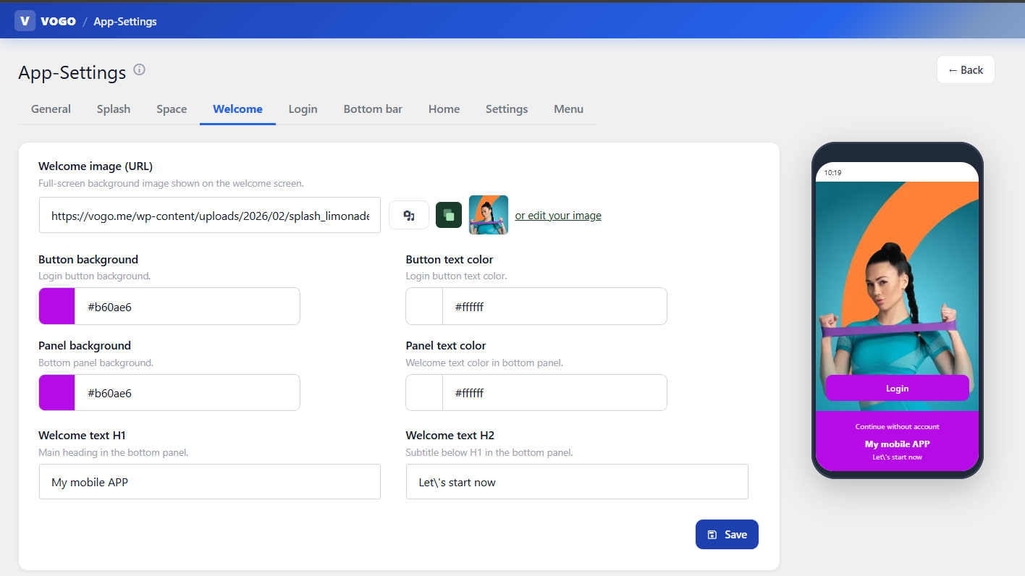
Fig. — The VOGO® MAF Framework — Mobile Application - App settings - Welcome screen configuration

4. MAF Architecture — Mobile + Plugin Backend + REST API
VOGO® MAF is built on three integrated layers that sync in real time via REST API: the Mobile App (Layer 1), Brand Control Center (Layer 2), and REST API with 200+ endpoints (Layer 3). Single Flutter codebase or React / Xcode option — native performance on iOS and Android.

The VOGO® MAF framework is organized into three integrated layers that work together in real time via JWT REST API, enabling customers to build and operate their own native mobile app — under their own brand, publishable in the Apple App Store and Google Play.
Layer 1 — Mobile App (iOS + Android)
- Codebase for mobile apps — native performance on both platforms
- State management: Bloc + Riverpod + GetX — scalable architecture
- Networking: Dio with smart retry, JWT interceptors, pretty-logger for debugging
- Secure storage: secure_storage + crypto for tokens and sessions
Layer 2 — Brand Control Center (web plugin)
- Web admin panel (WordPress plugin) — code-free app configuration, no Flutter / React / Xcode
- VOGO Space — each brand gets an independent space, activated via QR code
- 8 tabs: Splash, Welcome, Login, Bottom bar, Home, Menu, Settings, Space & Theme
- Additional modules: Push, Chat, AI Provider, Categories, User-Roles, Publisher Assistant
Layer 3 — REST API (200+ endpoints)
- Over 200 REST endpoints grouped into 10 domains: Account, Auth, Cart, Orders, Products, Chat, Payments, Brand-Admin, Provider, Document
- Authentication via JWT Secure, refresh tokens, role-based access across all channels
- Payments: native Stripe + Netopia + tokens integration — PSD2 / 3DS compliant
- Configurable hooks for key events: new order, payment confirmed, delivery in progress

The mobile app, Brand Control Center, and REST API operate in sync, sharing the same backend and the same data source — all with real-time synchronization.

Mature tech stack. Plugin-driven. Optional On-Prem.
You get an enterprise framework with a layered architecture (App, Plugin, API, Data), a mature stack (Flutter 3.x / React Native / Dart / PHP / MySQL / Cloud), with native integrations for ERP, CRM, marketplaces, BI, and existing eCommerce backends.
- Layered architecture: Mobile App (iOS/Android) + Brand Control Center (Web) + REST API
- Mobile: Dart, Bloc + Riverpod, Dio retry, Stripe SDK, Firebase Messaging
- Backend: PHP, MySQL, Redis, REST API documented in OpenAPI, SaaS or On-Prem deployment
- Security: JWT Secure, GDPR, SSL/TLS, 2FA, OTP, full audit log, end-to-end encryption
- Native integrations: Shopify, Woo, Presta, Magento, ERP (SAGA, SmartBill, SAP), payments, courier
- 99.9% uptime SLA, 24/7 monitoring, dedicated technical support

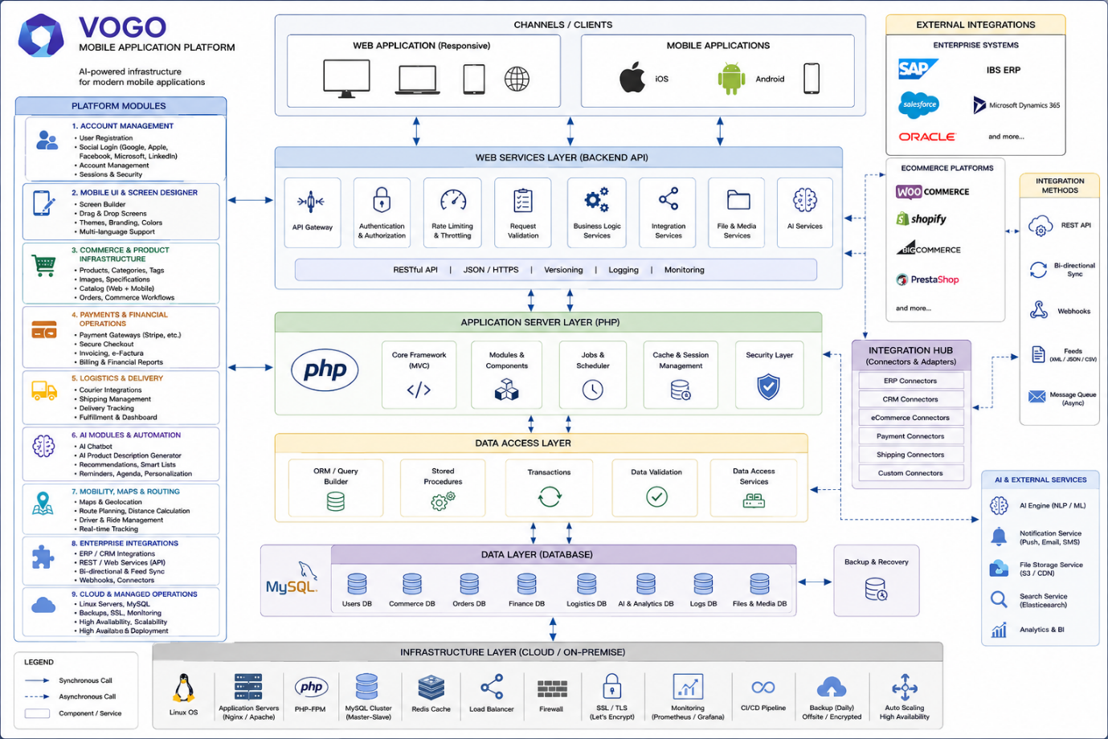
5. Mobile capabilities
VOGO® MAF builds native iOS and Android mobile apps for customers, partners, external users, or citizens— under the organization's own brand.
▸ Lets users access all relevant features of the backend directly from the mobile device  ▸ Native responsive design, automatically adapted to screen sizes — phone and tablet  ▸ Offline mode: data entry saved locally with shared_preferences + SecureStorage, sync on reconnect  ▸ Sends push notifications on any change, order status, booking, or request  ▸ All communication strictly over secure channels (SSL/TLS) between device and servers — end-to-end encryption  ▸ Supports login / register with: Google, Apple, LinkedIn, Facebook, Microsoft, Email; OTP via SMS, Email, and Authenticator app.  ▸ Lets users review their profile and start requests even in offline mode. Detects offline mode and informs the user.  ▸ Supports handwritten digital signatures directly on the device's touch screen  ▸ Generates and sends signed PDFs directly via email from the app  ▸ Generates and submits orders directly from the app  ▸ Enables rapid development of custom/tailored apps with assistance and pre-check for publishing in Google Play and the Apple App Store | 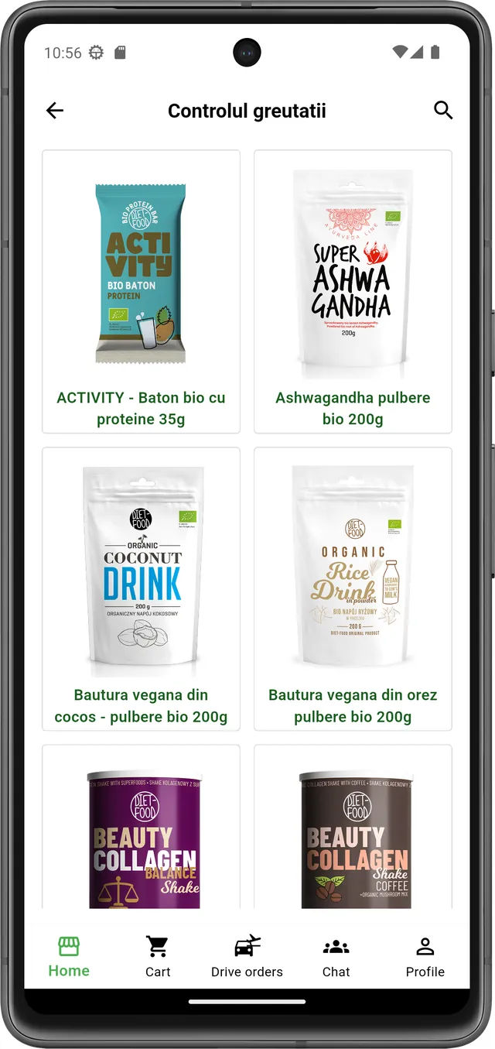  Responsive design — mobile view
6. Security & GDPR Compliance
- Robust authentication and authorization with differentiated profiles (customer, vendor, transporter, admin)
- Encrypts all communication between mobile device and servers via SSL/TLS
- Secure local storage: secure_storage (Keychain on iOS, Keystore on Android)
- Fully complies with GDPR requirements for personal data protection
- Provides a full audit log of every action on the platform and in the app
- JWT Secure — full authentication and token management across all channels
- GDPR & SSL/TLS — compliance with EU data protection regulations, end-to-end encryption
- 2FA & OTP via SMS / Email / Authenticator app — two-step verification
- Social Login — Apple, Google, Facebook, LinkedIn, Microsoft with a single click
- Full audit log — all actions are recorded and available for audit
- 99.9% uptime SLA — scalable, redundant infrastructure, 24/7 monitoring
- Google Play & Apple Store compliant — no SMS auto-fill, no READ_PHONE_STATE
- White-Label EU-Registered — your own brand, data stays with the customer, no vendor lock-in
- Integrates ROeID and eIDAS for verified digital identity at national and European level
- eIDAS integration — electronic identity recognition at European level (EU Regulation 910/2014)
- Sign in with Apple Relay — user email anonymization for identity protection
- Google Workspace SSO — login with a Google organizational account
- Integration with Keycloak — open-source Identity & Access Management (Red Hat), OIDC + SAML 2.0 + LDAP/AD federation support
- Integration with WSO2 Identity Server — enterprise IAM for SSO, multi-tenant, OAuth2 Authorization Server, OIDC Provider
- Support for OIDC (OpenID Connect) — Authorization Code Flow + PKCE for federated authentication
- Support for SAML 2.0 — Single Sign-On for integration with corporate IdPs (ADFS, Okta, OneLogin, Azure AD)
- Integration with LDAP / Active Directory — direct authentication against the corporate directory
- Microsoft Entra ID (Azure AD) integration — SSO with Microsoft 365 enterprise account
- LinkedIn Sign-In integration — for professional profiles, fast B2B onboarding
- GitHub OAuth integration — for dev / tech community target audiences

7. Mobile app generation — Build APK / AAB / IPA / IPS

VOGO® MAF builds native iOS and Android mobile apps for customers, partners, external users, or citizens — under the organization's own brand. VOGO® MAF includes an on-demand mobile app generation system, accessible directly from the Brand Control Center, with no need for the brand to set up build infrastructure, Flutter SDKs, Xcode, Android Studio, or macOS machines. The brand / company customizes the app from the panel (logo, colors, screens, integrations, AI), then requests a build for the desired platform — the VOGO technical team compiles the app with all brand settings applied and delivers the download link by email.
Generation flow
▸ The brand configures the app from the Brand Control Center (Splash, Welcome, Login, Bottom bar, Home, Menu, Settings, Theme + push, chat, AI)
▸ Goes to the Download Apps page and clicks the button for the desired build type (APK, AAB, IPA, or IPS)
▸ A request modal opens: date/time, build type, optional message for the technical team
▸ The request is automatically sent to VOGO by email + enters the Download history table with status Pending request
▸ The VOGO team compiles the build with the brand settings, release signing, and the brand's Apple/Google certificates
▸ The download link is sent to the administrator's email — the build stays available for later re-download
Supported build types
▸ APK (Android Package Kit) — for direct distribution, internal testing, pre-release, sideloading on Android devices without publishing in Google Play
▸ AAB (Android App Bundle) — the official format required by Google Play for Store publishing; allows automatic optimization per device configuration
▸ IPA (iOS App Store Package) — for distribution in the Apple App Store or via TestFlight; the standard iOS installation package
▸ IPS — iOS build artifact for testing and provisioning on Apple devices before publishing
Traceability & Audit
▸ Download history table in the panel with columns: Date, Type, Plugin version, App version, App identifier, Status, Download
▸ Visual icons per row for quick platform identification (Android green / Apple black)
▸ App version and VOGO Plugin version shown on every card and every request — full traceability
▸ Real-time request status: Pending request → processing → Completed with active link
▸ App identifier — the unique id of the brand's app for distinction in the Store
Benefits for the brand
▸ Zero local infrastructure — no Flutter SDK, no Xcode, no Android Studio, no Mac machine
▸ Zero mobile DevOps team — all builds compiled by the VOGO team on their own infrastructure
▸ Repeatable builds — every request is logged with the exact plugin and app version at the time of the build
▸ Asynchronous email flow — no waiting time in the panel, the link arrives when the build is ready
▸ Dedicated technical support — every request includes the option of a message to the VOGO team and a WhatsApp button for quick assistance (configurable per brand)
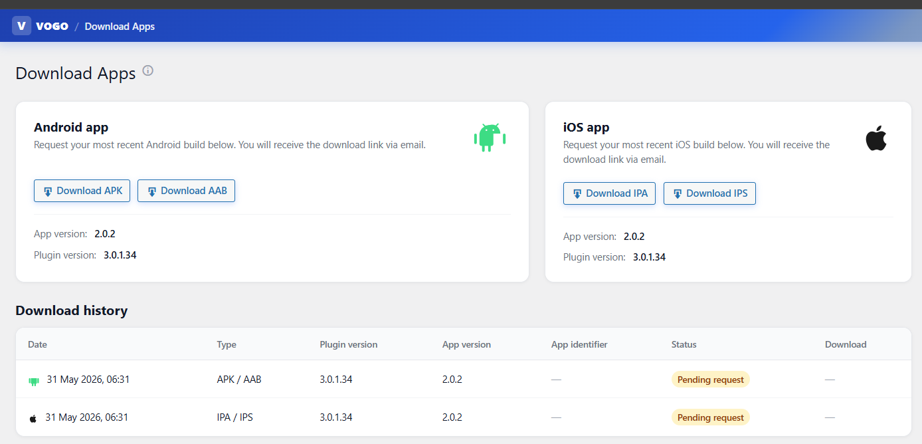
Fig. — The VOGO® MAF Framework — Download mobile apps APK-AAB-IPA-IPS

8. Key native capabilities — Mobile, Commerce, AI
Catalog & in-app experience
- Visual categories with custom icons, fast global search by name, description, tags
- Native product page: hero image, rating with reviews, price, quantity selector, Add to Cart
- 7 action icons: Back, Live View, Video call, Live chat, Wishlist, Recommend, Help
- Multi-vendor cart: products from different vendors in the same cart with automatic shipping calculation
Orders, Drive Orders & GPS
- Full Order Details: General (date, status, customer), Billing, Shipping, product list
- Profile with order history, totals, recurring orders, quick actions
- Drive Orders tab for delivery, taxi, transport, Mall Delivery — real-time GPS tracking
- Automatic PDF invoicing — generated and sent by email upon order confirmation
- Multiple payment methods: Cash on Delivery, Stripe SDK + Netopia card, Apple Pay, Google Pay
Push, Live Chat & Video Calls
- Text scroll banner — scrolling text at the top of the app (60–80 characters)
- Full Firebase push — text up to 300 characters, optional image, delivery status
- Live chat with a consultant from every product, operator responds from the Brand Control Center
- Product Live View — live streaming of the product directly in the app (Agora)
- 1-on-1 video call with a consultant for pre-purchase advice
- Recommend — peer-to-peer mechanism for validating vendors and products
AI & Smart Automation
- Automatic field pre-fill from the citizen profile (masked national ID, address, ONRC data)
- Conversational AI assistant 24/7 with HITL mode — handoff to a human operator when needed
- Real-time fraud detection on transactions and suspicious behavior
- Customer scoring and automatic segmentation for targeted campaigns
- Dynamic price optimization and predictive stock management
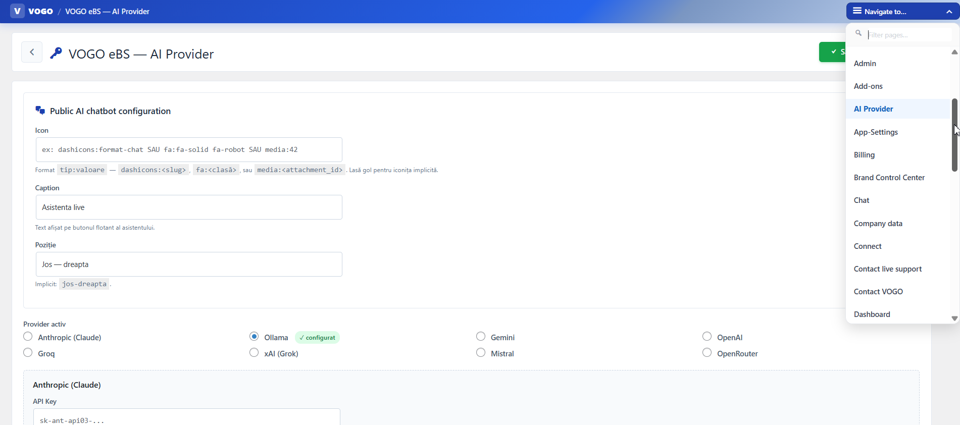

Address & location management
▸ Multiple delivery addresses per user with default address and inline editing ▸ Bidirectional geocoding: get_address_from_lat_long and get_lat_long_from_address with cache ▸ Auto-complete postal code from street via get_postcode_from_street_address ▸ Far-location detection (locationIsFarAway) with alert for out-of-zone deliveries ▸ City selector (cities) and areas of interest (areas_of_interest) with region filter ▸ Map Location Picker with Google Places autocomplete and pin drag on the map
Wishlist & Shopping List
▸ Per-product wishlist with add/remove and cross-device sync ▸ Separate shopping list with add/delete/markDone for future purchases ▸ Dedicated shopping_list table with history and sharing across family/team groups
Forum & Community
▸ Native discussion board: forum_post → forum_post_answer → answer_reply (3 levels) ▸ Edit and hide own posts with change history ▸ Mark-as-read per discussion (forum_post_no_to_read) with notifications for new replies ▸ Chat thread tied to a discussion (start_or_update_chat_thread) with multiple participants
Agenda & Calendar
▸ Personal calendar with agenda items (add, delete, markDone) and profile sync ▸ Dedicated calendar table with dates, times, priority, and status
Coupons & Promotions
▸ Discount coupons system with apply/remove at checkout and server-side validation ▸ Coupons API with code, percent/amount, validity, usage limit per user
Reviews & Ratings
▸ Product rating and review (rate-and-review, product-review) with 1–5 stars ▸ Post-delivery order review (order-review) with consultant/transporter rating ▸ Review moderation from the Brand Control Center
User documents
▸ Per-user document system (user_documents) with defined types (documents_def) ▸ Document data storage (user_document_data) — ID card, passport, proof of residence, contracts ▸ Get-vogo-documents for sync with the citizen profile

Loyalty & Referral
▸ Personal referral code per user (get/set vogo_get_myrefferal_code) ▸ Referred-by tracking for bonuses (set_referred_by, get_referred_by)
Mall Delivery & Picking Points
▸ Mall locations (mall_locations) linked to products and categories (category_malls, product_malls) ▸ Vendor picking points (vendors_picking_points) for order pickup
Drive Orders — full order-status flows
▸ 12 transient states: accepted → started → PACKAGED → courier → delivered + cancelled/rejected/closed/direct/address_not_found/client_not_found ▸ Real-time GPS position update (transporter_update_current_position) with tracking history ▸ Available orders for the transporter with instant accept/reject ▸ Order-transporter rejects tracking for analytics + automatic redistribution
Support Call (Agora-based)
▸ Video call with customer support: call/cancel/decline/end/status/refresh-token ▸ Support matchmaking via get-random-user for an available agent ▸ Thread calls (thread_calls) for history and call recording
Stripe integration (native Flutter SDK)
▸ SetupIntent for card saving without charging (create-setup-intent) ▸ Dynamic PaymentIntent with Ephemeral key and PaymentSheet bootstrap ▸ Saved cards with add/delete for 1-click payment ▸ Automatic 3DS Secure in PaymentSheet per PSD2
Netopia integration
▸ Charge, IPN webhook, status check, token management (netopia/token, /tokens) ▸ Webhook for asynchronous payment-status notifications
Vendor reports & analytics
▸ Low stock alert (vendor_report/low_stock) with configurable threshold per product ▸ Performance report (vendor_report/performance) with sales and conversion KPIs ▸ Profitability report (vendor_report/profitability) with per-product margin ▸ Customer interactions (get-customer-interactions) and earnings summary
Push & Notifications
▸ Notification list (notification-list) with message history per user ▸ Push log (push_log) with traceability per device and user ▸ Device tokens (device_tokens) with lifecycle management and logout revocation ▸ Register-device on my-account for user-device pairing
Bank & Payouts (vendor)
▸ User bank accounts with multiple IBANs per vendor (native Flutter IBAN validation) ▸ Earnings summary with net-of-commission calculation and available balance
Audit & Compliance
▸ Audit log table recording every user action for GDPR compliance ▸ Activate-and-get-updates calls for tracking plugin versions and updates ▸ Geocode cron (run_geocode_cron) for automatic completion of pending addresses
Bulk import & Categories
▸ Bulk category import from WordPress (import/attach_categories_wp) ▸ Image processing (import/process_images) with resize and optimization ▸ Bulk product publishing (import/publish) from CSV/Excel
Saved cards & gateways
▸ Multiple payment gateways at checkout (checkout/payment-gateways) ▸ Set-payment-method per order with saved preference ▸ Saved cards list per user (saved_cards, delete_card) with PCI-compliant tokenization

Privacy & GDPR
▸ Vogo_get_privacy endpoint for per-brand policies (configurable from admin) ▸ Delete account (account/delete, deleteAccount) with GDPR-compliant cascade purge
Multi-language (native i18n)
▸ Supported languages: Romanian, English, French, German, Bulgarian, Czech, Greek ▸ Language change from settings with instant reload — no app restart; extensible by configuration to any other language
Brand Pairing & Multi-Brand
▸ Brand pairing via QR code with native mobile_scanner ▸ List of brands (brands) with activation per BrandElement in AppSecureStore ▸ Brand-admin endpoints for runtime configuration
Predefined Q&A
▸ Library of predefined frequent questions (predefined_qa) for the AI assistant ▸ Contextual training of the chatbot on brand FAQs
User Groups & Segmentation
▸ User grouping in user_groups with categories (user_group_categories) ▸ Members per group (user_group_users) — useful for membership/subscription programs

9. Integrations & Interoperability
VOGO® MAF integrates natively with a wide ecosystem of services — from eCommerce backends to payments, ERP, CRM, marketing, AI, and logistics — so customers can extend the mobile app without code changes.

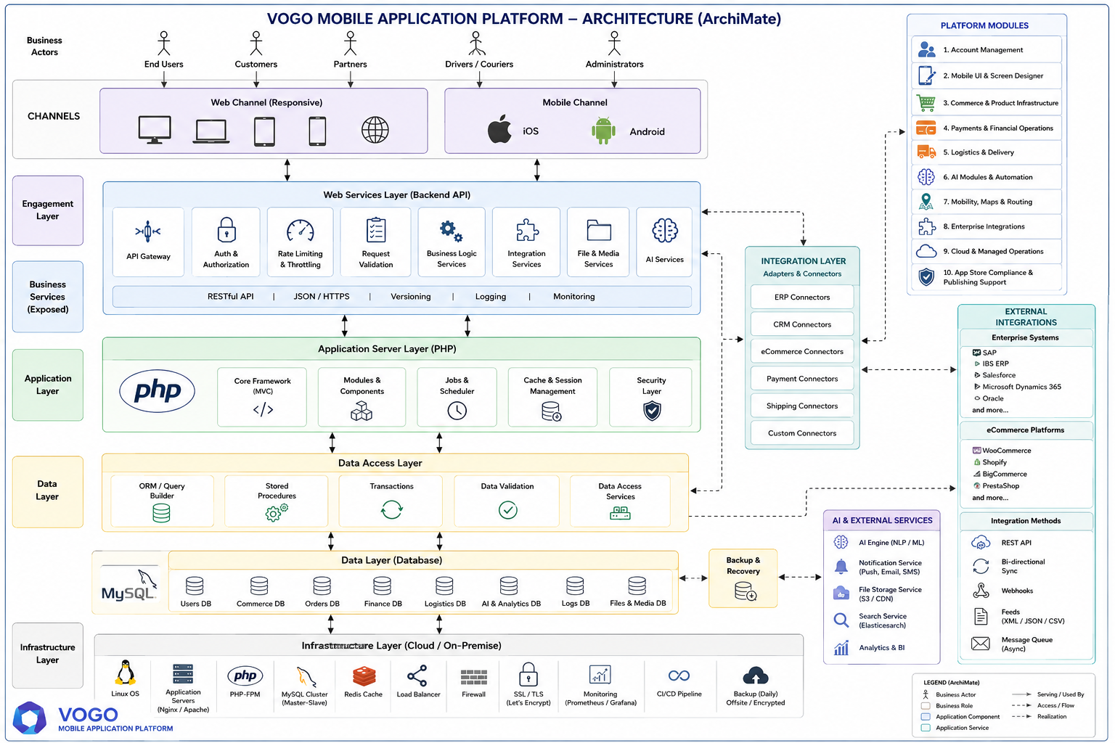

Backend Sync | Bidirectional real-time sync via REST API: products, stock, orders, customers, notifications.
Online payments | Native Stripe SDK + Netopia + PayU + Apple Pay + Google Pay + COD — PSD2 and 3DS compliant.
Courier & Logistics | Integrations with courier companies, Drive Orders with Google Maps + Polylines, automatic AWBs.
Invoicing & ERP | Automatic PDF generation, integration with ERP/accounting systems (SAGA, SmartBill, Oblio, SAP).
Marketing & CRM | Firebase push, advanced segmentation, email/SMS, WhatsApp, loyalty and referral programs.
AI & Support | Live chat with HITL, smart recommendations, fraud detection, Agora video call, Live View.
Digital identity | Social Login (Apple, Google, Facebook, LinkedIn, Microsoft), OTP, 2FA, JWT, GDPR compliant.
Analytics & BI | Sales reports, user behavior, conversions, configurable dashboards.
Industries & use cases

- Native eCommerce – mobile app on top of Shopify / Woo / Presta / Magento or a VOGO eBS store
- eServices – clinics, practices, agencies — booking + payment + chat in-app
- HoReCa & Food delivery - restaurants, delivery, digital menu, QR ordering, table reservations
- Events & Ticketing — festivals, conferences, concerts, sports — QR digital tickets, check-in
- Education & e-Learning — online courses, enrollments, materials, certification, communication with teachers
- Loyalty & Membership — digital member card, points, vouchers, referral, subscriptions
- Transport & Drive Orders — taxi, courier, airport transfer, GPS tracking, AWB, doorstep delivery
- eGov — Public services — citizen profile, ROeID, eForms, handwritten signature, eSignatures
- eHealth & Wellness — appointments, telemedicine, prescriptions, subscriptions, in-app loyalty
- Industry & B2B — B2B catalog with contract pricing, order portal, ERP integration, app for sales reps
- NGOs & Community — online donations, merch store, volunteer portal, mobile app for the community
- Associations & Members — chambers of commerce, federations, cooperatives — member portal, communication, electronic voting
- Tourism — bookings, ticketing, local guides, mobile app with destination catalog and map
- Real Estate — fault reporting, rent payments, tenant documents, request-approval notifications
- Retail & Franchises — multi-vendor, multi-brand, white-label app per franchise, network-wide sync
- Beauty & Wellness — salons, coaching, retreats, organic products, bookings and payment
- Last-mile — technical / home services — plumber, electrician, cleaning, repairs — booking + payment + tracking
- Coaching & Entertainment — coaching sessions, wellness retreats, cinema tickets, live broadcasting
- Transport & Last-mile delivery — Drive Orders with GPS, real-time tracking, AWB, doorstep delivery
- B2B & Associations — member services catalog, B2B portal with contract pricing
Benefits for B2B customers & Partners
VOGO® MAF is built for organizations, distributors, resellers, transporters, influencers, and partners who want to launch or consolidate their mobile presence without investing in their own development. The framework delivers measurable results in weeks, not months.

Time-to-Market  Fast launch  From kickoff to live in App Store and Google Play in 2–6 weeks. | White-Label  Your own brand  Logo, colors, splash, welcome, login — all customized with no code. | Cross-Platform  One code, two platforms  A single codebase for iOS and Android / React Native / Xcode — native performance.
AI-Ready  Integrated assistant  HITL chat + RAG/Ollama/LangChain, connectable to OpenAI, Claude, Groq, Gemini. | Plugin-Driven  8 tabs, no code  Splash, Welcome, Login, Bottom bar, Home, Menu, Settings, Theme — from the browser. | GDPR  EU-Registered  JWT, OTP, 2FA, SSL/TLS, full audit log, 99.9% uptime SLA, data stays with the customer.

