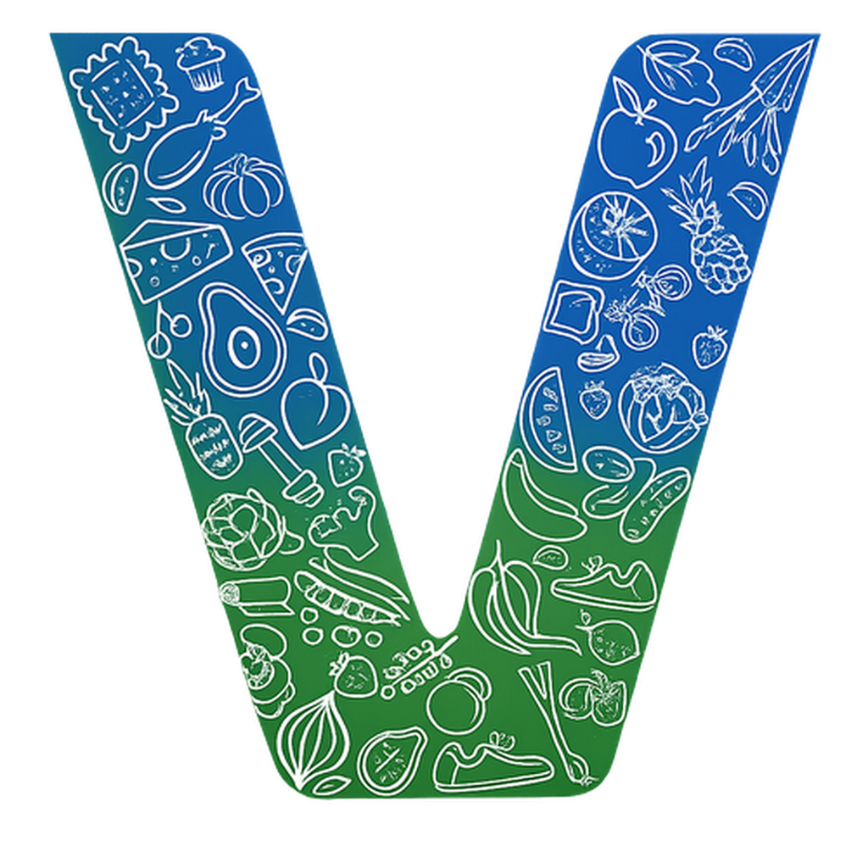 |  | 




®

One Suite.
Unlimited Possibilities

Integrated platform for accelerating growth, adopting
top technology and improving the organization.

VOGO eBS – Enterprise Business Suite is an open source, modular and
extensible platform that helps organizations build digital solutions faster,
collaborate more effectively and scale processes in a modern, secure and
flexible ecosystem, in order to remain competitive in a changing digital
environment.
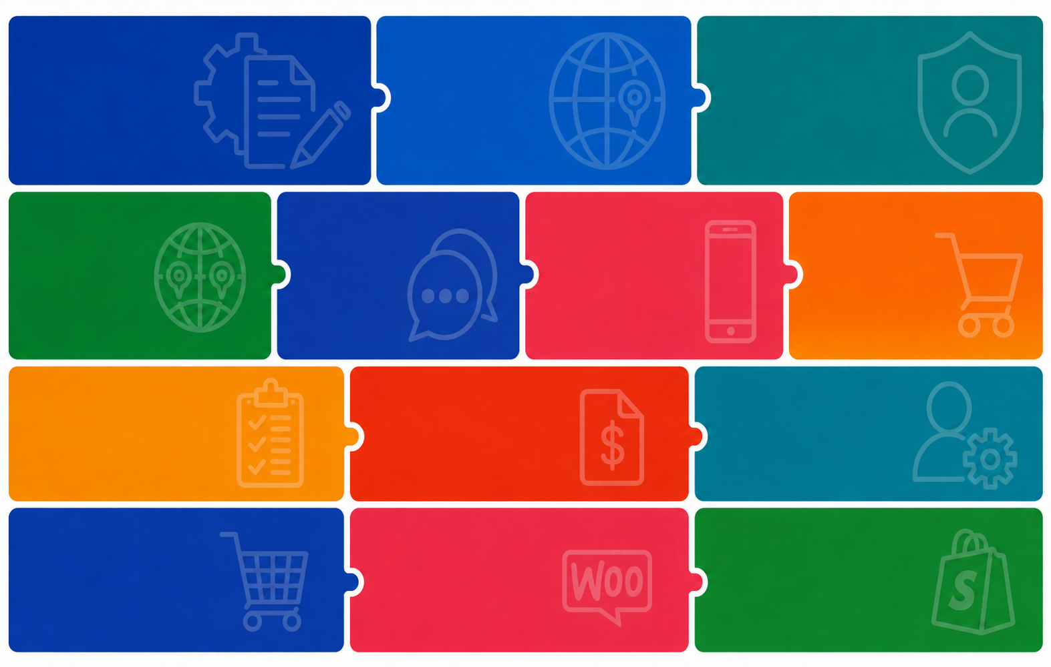
VOGO
Portal
Identity
Forms
& User Access
Management
& Digital
Services Designer

AI
Mobile
Application
Framework

Order
Management
GIS
Agentic
Solutions

Human
Resources
Invoices
Projects

eCommerce
Framework
VOGO eBS for
shopify
VOGO eBS for
wooCommerce



Ask for
more
VOGO eBS for
Microsoft
VOGO eBS
for
ORACLE
VOGO eBS
for
SAP

VOGO eBS Platform Modules

Each module covers a specific business domain. Together they form the integrated ecosystem that modernizes and streamlines the way organizations operate, grow and innovate. Technology has become a must for adaptability.
  Forms & Digital Services Designer  Create and publish digital forms and services without code. Eliminate paper, accelerate interactions and deliver a modern experience to your customers, from anywhere. No-code platform for creating web and mobile forms for digital services to citizens and customers. Web & Mobile Apps | VOGO Portal  Company web portal for presenting the organization, its services and digital interaction with customers and citizens. A unified digital space through which partners, customers and internal teams access information, initiate requests and collaborate in real time. Easy maintenance, administration and new page definition.
  Identity & User Access Management  Control who accesses what and when. Enterprise security with granular roles, SSO authentication and complete audit logs — compliance without compromise. |   GIS  Visualize operations on the map in real time. Make faster decisions in logistics, delivery and field ser vices, based on precise geographic data. GeoServer, Open Layers, PostGIS
  AI Agentic Solutions — Chatbots, Assistants & Automation (LLM, RAG, LangChain and more)  We build custom AI chatbots, assistants and agents, integrated directly into your existing systems — CRM, ERP, ticketing, document processing — using top LLM APIs (OpenAI, Anthropic, Google) or open-source models running locally for full data privacy. From intelligent knowledge bases (RAG) and multi-agent workflows with persistent memory and GDPR security, to cloud or on-premise deployment — we transform AI from a generic tool into a real, measurable competitive advantage for your organization. | 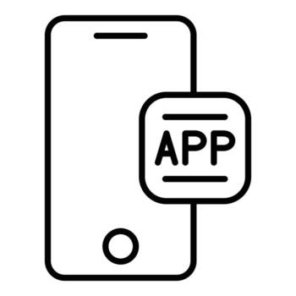  Mobile Application Framework (VOGO MAF)  The VOGO MAF Framework library covers the entire mobile application lifecycle — secure authentication (Apple, Google, Facebook, OTP/PIN), real-time maps and routes, invoices and payments, Firebase push notifications, QR/barcode scanning, integrated chat, user profile, eCommerce, REST/XML integration. A single codebase, assisted deployment on Apple Store and Google Play, under your brand. Faster time-to-market, reduced costs and risks compared to a solution built from scratch. All integrated with VOGO Enterprise Business Suite. Already have an eCommerce site? Publish it quickly in a mobile app via VOGO plug-in for E-COMMERCE and VOGO MAF Essentials.
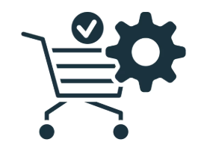  Order Management — Customer Order Management  Manage the entire order lifecycle — from order receipt, automatic mapping with supplier orders and intelligent split by vendor, to status management, responsible parties, deliveries and payments, with real-time notifications for every stakeholder. Three synchronized native interfaces — customer app, vendor app and administration backend, available both mobile and web — plus complete BI reporting for data-driven decisions. Manage every order from placement to delivery with precision. Reduce errors, accelerate order fulfillment and increase customer satisfaction. |   VOGO Enterprise Projects - Project Management  Define projects with complete WBS structures, teams and roles, financial and operational KPIs, risks and mitigation measures — all automatically monitored in real time, with Gantt, Kanban and open issues views for each phase. Integrated with ERP systems (accounting, fina ncial, fixed assets and cost centers, budgeting, GIS), VOGO Projects transforms project management from a manual process into a complete control system, from initiation to final financial reporting. Plan, execute and monitor projects across the entire organization. Aligned teams, respected deadlines and budgets under control — total visibility in real time.
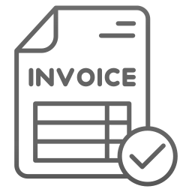  Integrated Invoicing  Invoices are automatically issued based on orders. Manual invoice issuance options. e-Invoice integration. Integrated invoice payment options with secure and authorized payment processors. Reports and rem inders automated. |   Human Resources  Manage your staff simply and compliantly, including the organizational chart. Integration with the Projects, GIS and User Management modules. Free up precious time for what matters: performance and organizational culture.
  Mobile eCommerce Framework  Launch or scale your online store with a robust and flexible engine — optimized for performance. Built for high performance, superior co nversion rates and sustainable growth. Product management, online store and dedicated mobile app, customer orders, invoicing, collections (card, paypal, bank, Google Pay, Apple Pay), deliveries, BI reports for business management. Integrated with ERP systems. |   Collections & Payments — Payment Management  Accept collections and make payments online through any modern method — bank card, IBAN transfer, digital wallets (Apple Pay, Google Pay) and recurring payments with automatic subscriptions — with secure processing, conf irmity with PCI DSS and native multi-currency support integrated in your platform. Manage complete operations, split payments to multiple vendors, real-time cashflow reporting and automatic reconciliation with invoicing and accounting modules.
  VOGO eBS for Shopify  Bring the enterprise power to your Shopify store. Integrate inventory, logistics and CRM without changing your platform. Publishyour Shopify store mobile app on the Apple Store and Google Play |   VOGO eBS for WooCommerce  Connect your WooCommerce store to the complete VOGO eBS ecosystem. Real-time sync for pro ducts, orders and customers, without complex configurations. Deliver your store's mobile app on the Apple Store and Google Play.
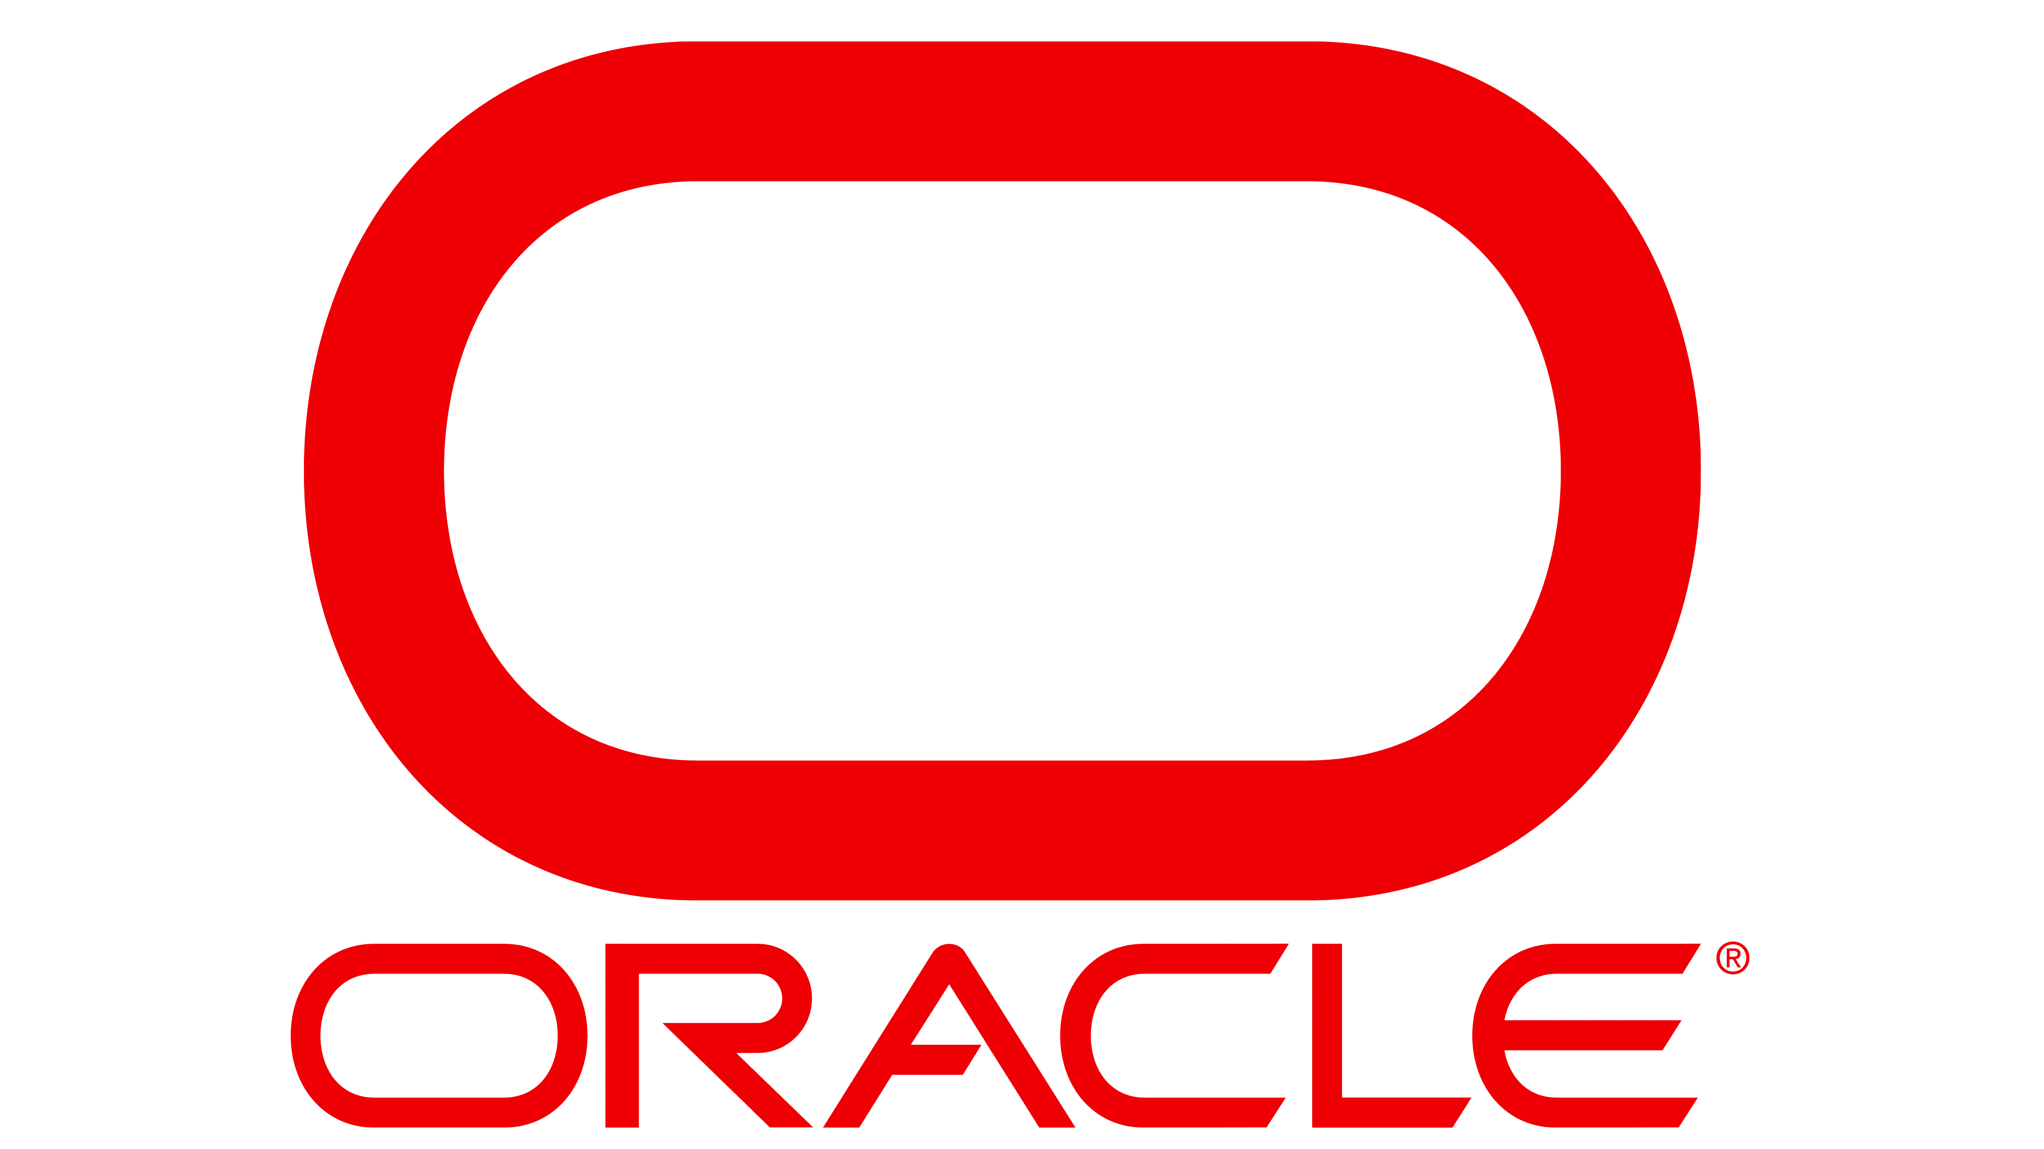  VOGO eBS for Oracle  Connect your Oracle infrastructure to the VOGO eBS ecosystem. Real-time data exchange without operational disruptions — your enterprise as one coherent whole. Mobile Applications. |   VOGO eBS for Microsoft D365  Integrate Microsoft 365, Dynamics and Azure with VOGO eBS. Your teams work in the tools they know — now amplified with complete enterprise capabilities mobile app.
  VOGO eBS for SAP  Optimize the integration between SAP and digital channels. Synchronized data, automated processes and an organization that operates as one unit, from ERP to front-end. | 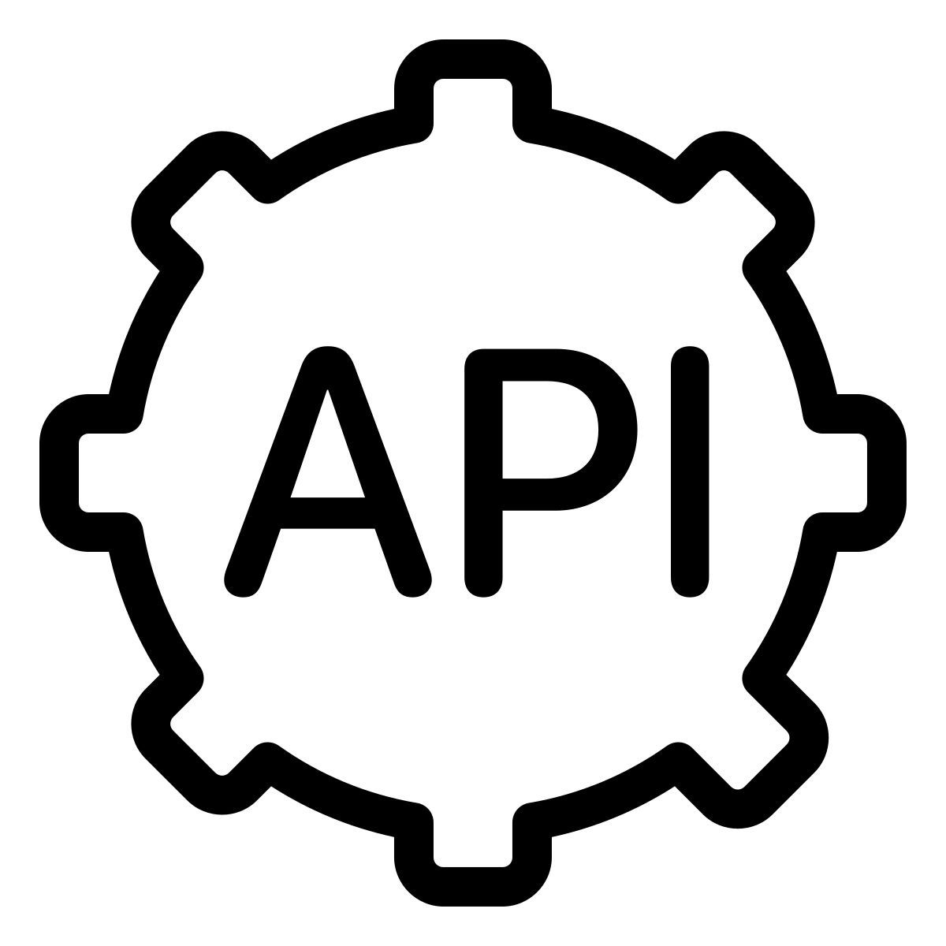  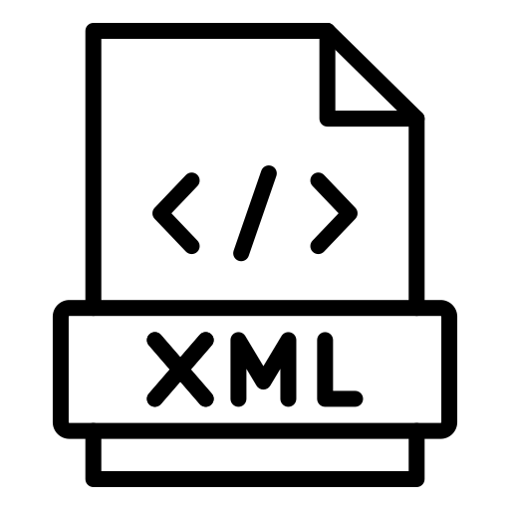  VOGO eBS Universal Connector  Integrate any ERP, CRM or enterprise platform with VOGO eBS via REST or SOAP web services. Regardless of the existing system.
Custom
Ask for more — Custom Modules & Connectors
Can't find exactly what you need? Contact us to clarify the specific requirements of your business.
Contact the VOGO team for an applied discussion on the modules relevant to you.
vogo.me/ebs | ebs@vogo.family | +40 742 203 383 (Tel & WA)




