VOGO eBS
Enterprise Business Suite
One Suite.
Unlimited Possibilities.
An integrated platform to streamline operations, accelerate growth and drive digital transformation.
VOGO eBS is a comprehensive, modular and extensible enterprise platform designed to empower organizations with scalable digital capabilities.
Forms  and  DigitalServices  Designer | Vogo  Portal | Identity  and Access  Management
GIS | AI  Chatbot | MAF  Mobile Applications  Framework
Project  Management | Invoices | Human  Resources
e-Commerce  Framework  Foundation | VOGOO eBS  for  WooCommerce | VOGOO eBS  for  Shopify

VOGO eBS  Connector: | SAP | Oracle | Microsoft  D365

MODULAR & INTEGRATED  All the tools you need,  seamlessly connected. | SECURE & COMPLIANT  Enterprise-grade security  and governance. | SCALABLE & FLEXIBLE  Built to grow with  your business.

Transform. Integrate. Succeed.

 |  | 

®

One Suite.
Unlimited Possibilities

An integrated platform to streamline operations,
accelerate growth and support digital transformation.
VOGO eBS – Enterprise Business Suite is a
comprehensive, open source, modular and extensible
platform designed to empower organizations with
the tools they need to innovate, collaborate and scale in a
digital-first world.
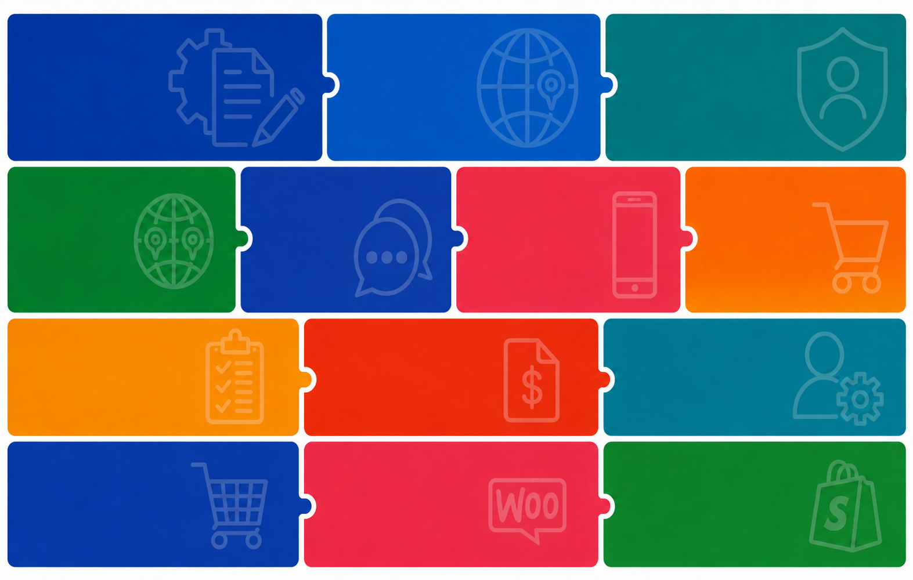
VOGO
Portal
Identity
Forms
& User Access
Management
& Digital
Services Designer

Mobile
Application
Framework

Order
Management
AI
GIS
clients chatbot & backend assistant

Human
Resources
Invoices
Projects

eCommerce
Framework
VOGO eBS for
shopify
VOGO eBS for
wooCommerce

One Suite.  Unlimited Possibilities.  An integrated platform to streamline operations,  accelerate growth and support digital transformation.  VOGO eBS – Enterprise Business Suite is a comprehensive, open source, modular and extensible platform designed to empower organizations with  the tools they need to innovate, collaborate and scale in a digital-first world. | WHITE PAPER  
   | VOGO eBS  Enterprise Business Suite

