VOGO eBS  ®  Enterprise Business Suite | DATASHEET  VOGO eBS eCommerce Suite  The AI Digital Commerce & Logistics Ecosystem







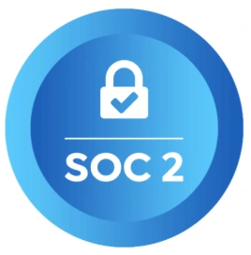
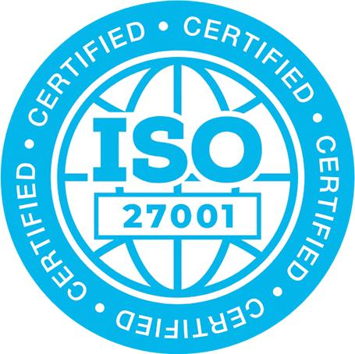
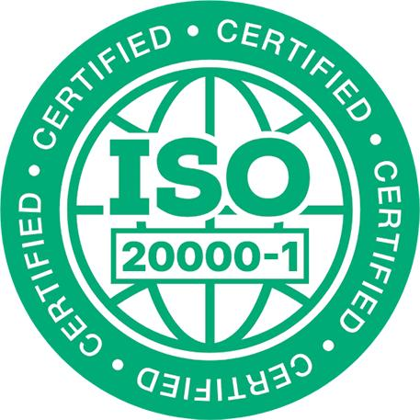
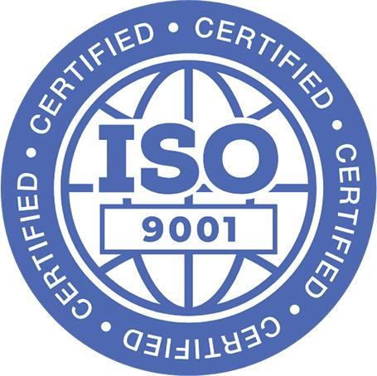

1. Overview – VOGO® eBS eCommerce Suite
VOGO® eBS eCommerce Suite is an integrated platform for the rapid creation, configuration, and operation of e-commerce applications, designed for organizations that want to quickly digitize their commercial activity, expand their online presence, and offer their customers modern interaction channels. The platform enables the accelerated delivery of a corporate website for the organization, with content management, publishing of informational pages, commercial sections, and multi-language options, so that the organization can communicate effectively with different audiences — at local, national, or international level (multi-language and multi-territory) — both through a web-based application and a mobile application (published in the Apple App Store and Google Play)
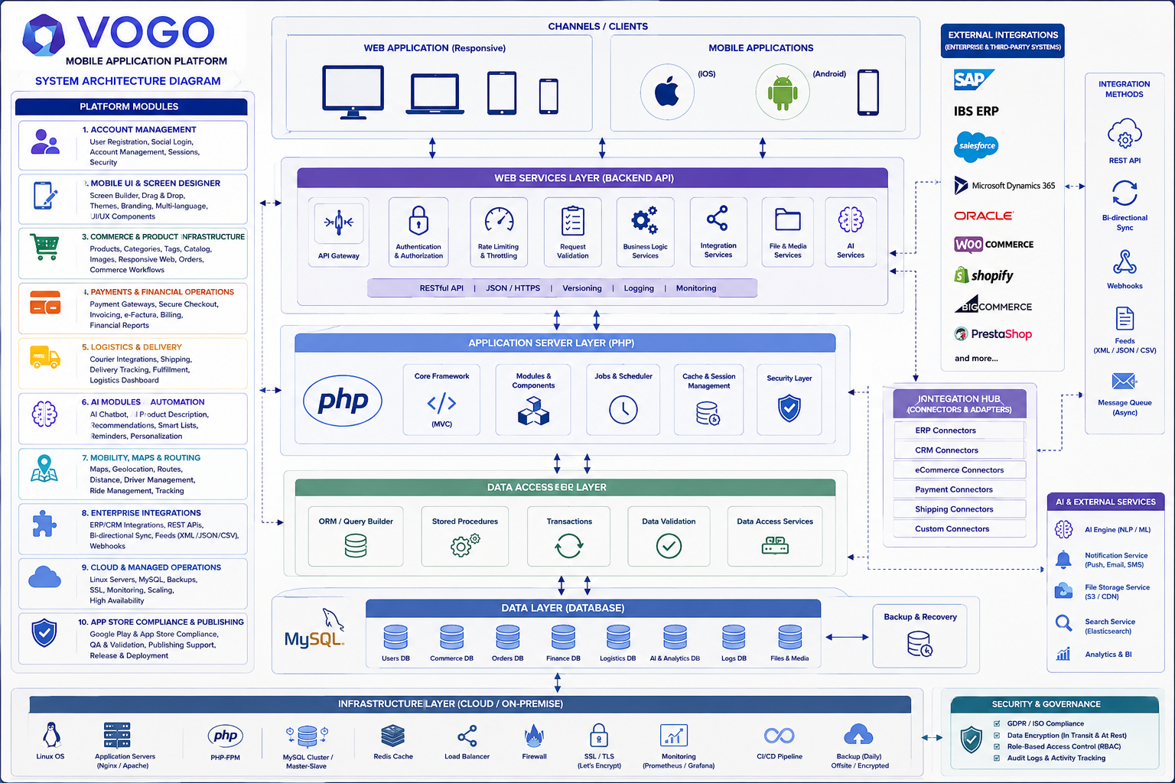
Fig. — The VOGO eBS eCommerce Suite ecosystem
The online store component provides complete e-commerce functionality, including product category management, product listing and presentation, pricing policies, order placement and tracking, customer management, customer accounts, delivery, invoicing, and operational reporting. Through these capabilities, VOGO® eBS eCommerce Suite supports the entire digital commerce flow — from product display to order processing and performance analytics.
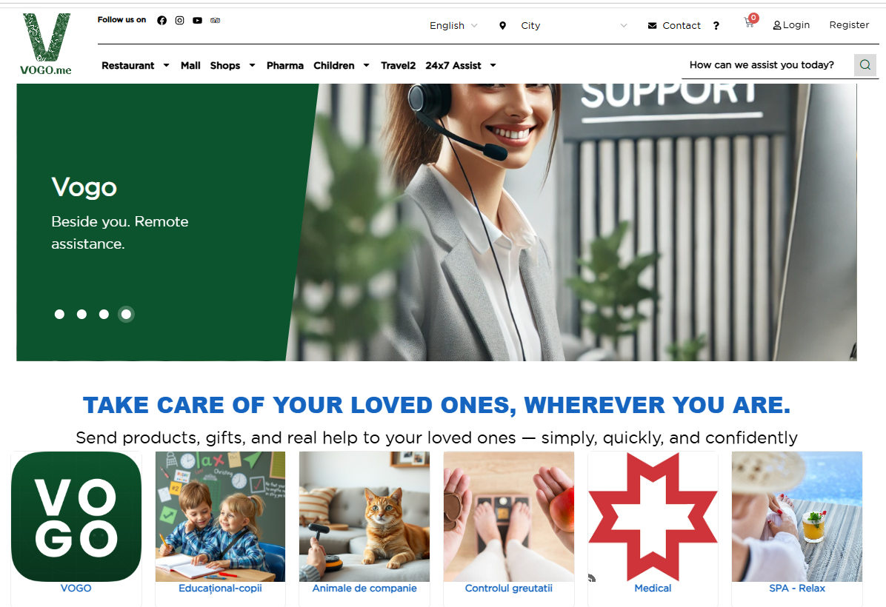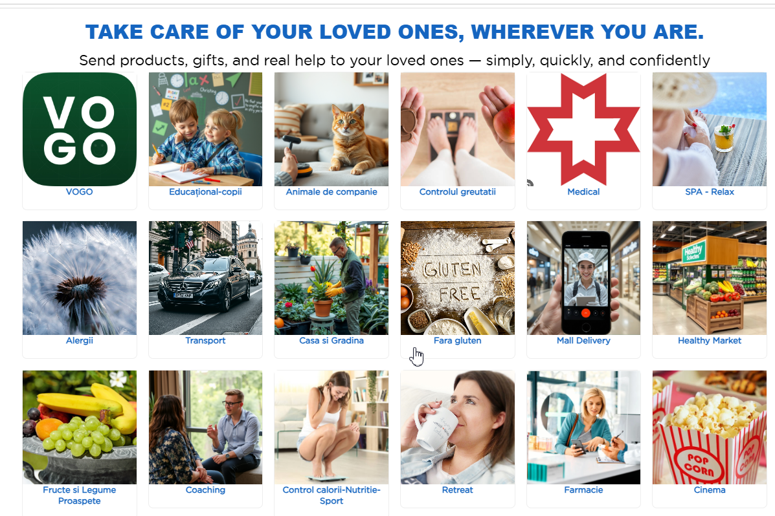

The platform also includes BI analytics and reporting components that enable monitoring of commercial activity, orders, customers, products, and management KPIs. These reports support business decisions and give the organization a clear view of digital channel performance. A distinctive element of the platform is the integration of AI assistants. VOGO® eBS eCommerce Suite can include an AI customer assistant, designed for support, user guidance, and improving the buying experience, as well as an AI assistant for the store backend, dedicated to helping internal teams manage content, products, training, usage guidance, order processing, and the efficient running of operational processes.
The platform enables the rapid publishing of mobile applications in the Apple App Store and Google Play, automatically connected to the online store. The mobile apps fetch and sync information such as products, stocks, orders, customers, and other relevant data — giving the organization a modern mobile channel integrated with its existing e-commerce infrastructure.

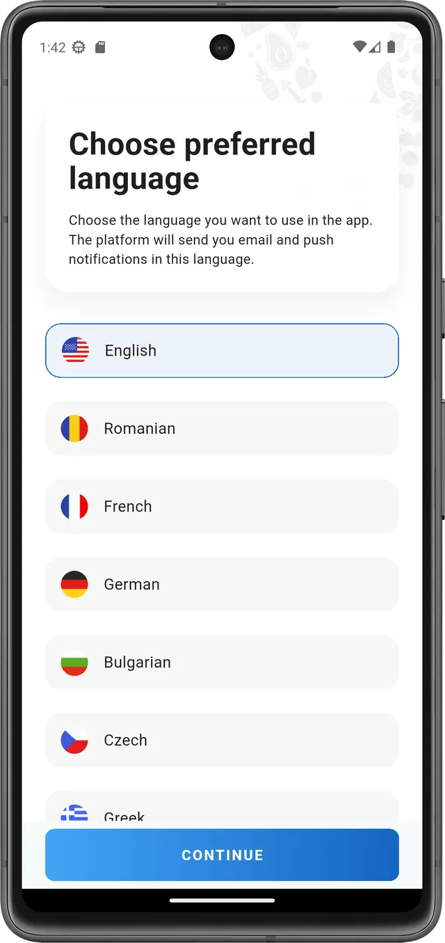  Multi-language | 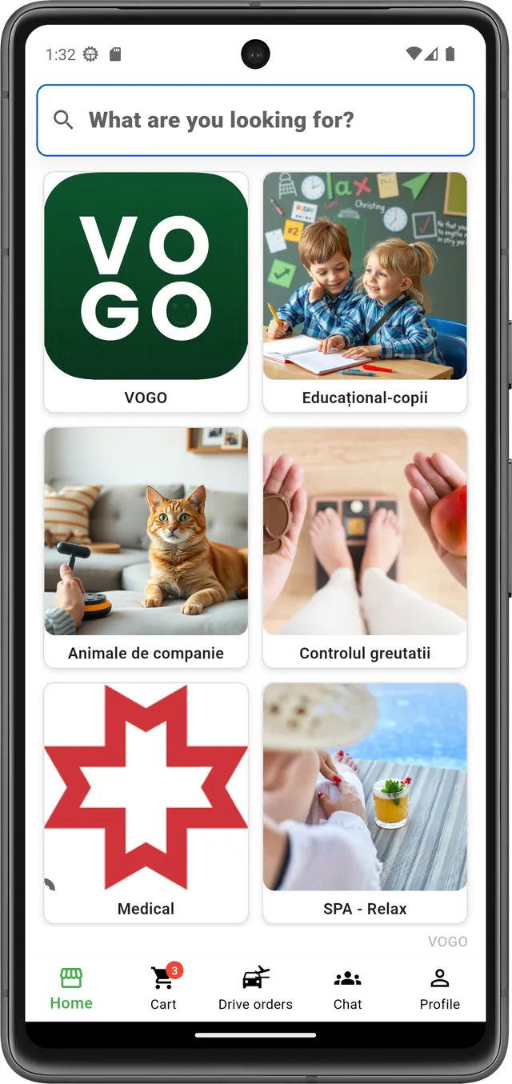  Product categories | 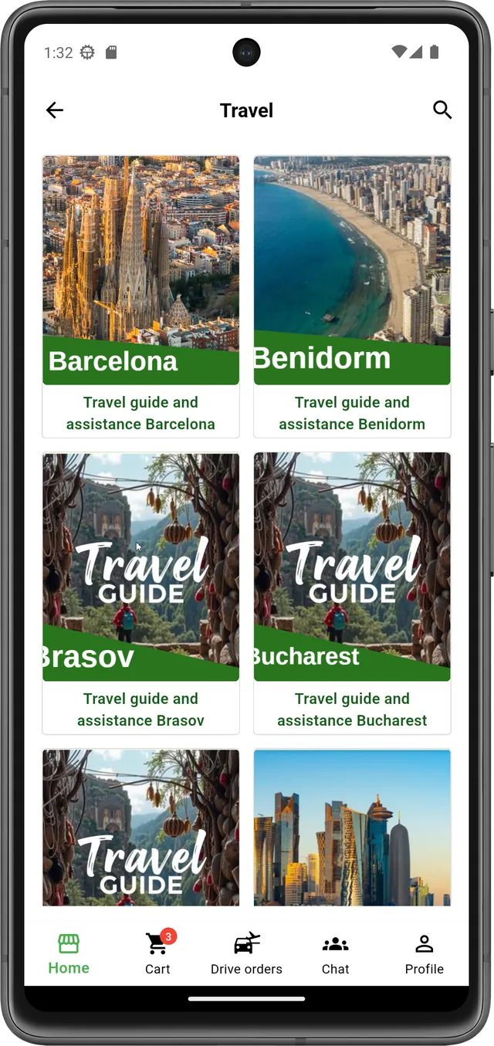  Products | 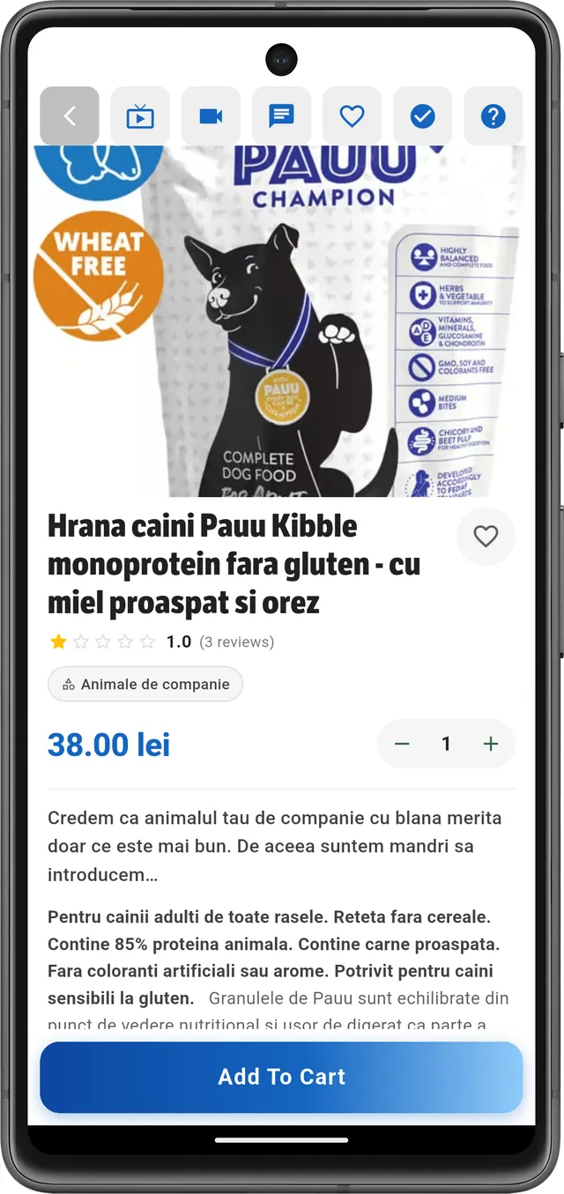  Product details

Beyond classic e-commerce features, VOGO® eBS eCommerce Suite enables the publication of online services and digital forms for customers. This allows organizations to offer additional digital processes — online requests, applications, contact forms, custom services, or other electronic flows tailored to their activity.
Thanks to its modular architecture, VOGO® eBS eCommerce Suite can be used either to rapidly launch a complete online store or to extend an existing digital platform with mobile apps, online services, AI components, and reporting capabilities. The solution is designed to reduce time-to-implementation, standardize delivery, and provide organizations with a scalable technology foundation for digital commerce.

2. What VOGO® eBS eCommerce Suite solves for you?
1 I need ... A corporate website — modern, mobile-responsive, multi-language

What you get from VOGO® eBS:
A professional website, ready to launch
- Responsive website (desktop, tablet, mobile) with your brand and custom domain
- Pages: Home, About us, Services/Products, Contact, Blog, GDPR policies
- Contact form + email integration, Google Maps, social media
- Basic SEO, EU hosting, SSL certificate, GDPR-compliant, multi-language EN/RO
- Simple CMS for content updates with no technical skills required
- WCAG accessibility
- Modern 24/7 AI & HITL assistant for customer interaction, optimized with RAG, Ollama, LangChain, and LangGraph — running on open-source models or integrated with OpenAI, Anthropic Claude, Groq, or Gemini.

2 I need ... An e-commerce store

What you get from VOGO® eBS:
Complete Online Store — Web
- Everything in section 1, plus the items below:
- Product catalog with categories, detailed listings, photo galleries, global search
- Shopping cart, one-page checkout, online payments (Stripe, Netopia, PayU, Apple/Google Pay)
- Order, customer, stock, price, and promotion management — all from the browser
- Automatic PDF invoicing, integration with SAGA/SmartBill/Oblio
- Courier & Drive Orders with GPS, home delivery or pickup from premises
- Sales reports dashboard, conversions, top products, customer behavior
- Modern 24/7 AI & HITL assistant for both customer interaction and store backend, optimized with RAG, Ollama, LangChain, and LangGraph — running on open-source models or integrated with OpenAI, Anthropic Claude, Groq, or Gemini.

3 I need ... A mobile app connected to your store

What you get from VOGO® eBS:
Native iOS + Android app under your own brand
- Everything in section 2, plus the items below:
- Native app publishable in the App Store and Google Play with your logo and colors
- Connects to your existing store (Shopify, WooCommerce, PrestaShop, Magento or any other solution exposing REST-API web services) OR to the new VOGO store
- Real-time sync: catalog, prices, stock, orders, customers — all in one place
- 9 configurable screens (Splash, Welcome, Login, Home, Menu, Settings, etc.) — no code required
- Push notifications, live chat, product Live View, video call with consultant
- In-app Drive Orders with GPS + 1-click payment with saved methods

4 I need .... An AI assistant for customer relations / partners / external users / citizens

What you get from VOGO® eBS:
App AI Chatbot 24/7 + Human-in-the-Loop
- Conversational assistant trained on your catalog, FAQs, and policies
- Answers 24/7 questions about products, prices, availability, delivery
- Personalized product recommendations based on customer history and behavior
- HITL mode: hands off the conversation to a human operator when needed
- Fraud detection on transactions and customer scoring for automatic segmentation
- Available on the website, in the mobile app, and in the Brand Control Center
- Modern 24/7 AI & HITL assistant for both customer interaction and store backend — optimized with RAG, Ollama, LangChain, and LangGraph — running on open-source models or integrated with OpenAI, Anthropic Claude, Groq, or Gemini.
- More details in VOGO_eBS_AI_DataSheet_EN.pdf

5 I need .... Online services for my customers — customers / partners / external users / citizens

What you get from VOGO® eBS:
Configurable eServices Portal & eForms, eSignatures, ROeID / eIDAS integration
- Portal with a catalog of services organized by category (appointments, consultations, subscriptions, etc.)
- 4-step request wizard: Description → Form → Preview → Submit
- Service payment directly from the portal, or auto-generated quote/invoice
- Appointment calendar, automatic notifications (email, SMS, push), live status
- Service configuration from predefined templates or from scratch — no code required
- Modern 24/7 AI & HITL assistant for both customer interaction and store backend — optimized with RAG, Ollama, LangChain, and LangGraph — running on open-source models or integrated with OpenAI, Anthropic Claude, Groq, or Gemini.
3. WCAG Accessibility & Live AI Assistant
The platform meets the WCAG standard for web accessibility and includes a conversational AI assistant permanently available to users.
▸ Compliant with the Charter of Fundamental Rights of the European Union and Article 9 of the UN Convention on the Rights of Persons with Disabilities
▸ Provides a complete accessibility panel: text resize, high contrast, dark mode, grayscale, readable font, link underline, large cursor, animation stop
▸ Supports screen readers, keyboard-only navigation, and adjustable contrast
▸ Includes the Live AI Assistant in the corner of the page, active 24/7, ready to guide the user through any service
▸ The AI assistant operates in Human-in-the-Loop (HITL) mode: it can hand the conversation off to a human operator when needed
4. System architecture
The system is built using modern, open-source components across all architecture layers: database, application server, and specific applications.

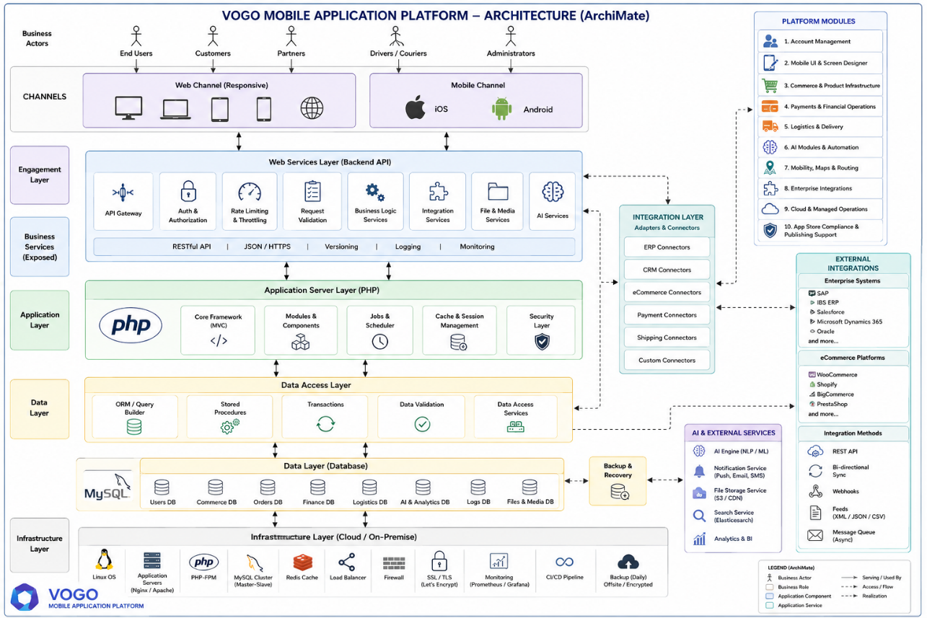
Fig. — System architecture — ArchiMate view
The VOGO® eBS eCommerce Suite is organized into three integrated layers that work together in real time, enabling customers to build and operate their own digital commerce ecosystem — from the online store to the branded mobile app and delivery logistics.
Layer 1 — Online Store (Web)
- Complete product catalog with visual categories, detailed listings, photo, video, and 360° galleries for each product
- Multi-vendor shopping cart, one-page checkout, secure payments with Stripe, Netopia, EuPlătesc, PayU
- Order, customer, stock, price, and promotion management — all from the browser, no technical skills required
- Sales reports, configurable dashboards, Excel/CSV export, and integration with accounting systems
Layer 2 — Mobile App (iOS & Android)
- Native app publishable under the customer's own brand in the App Store and Google Play
- VOGO Space — each brand gets an independent space, activated via QR code
- 9 configurable tabs (General, Splash, Space, Welcome, Login, Bottom bar, Home, Settings, Menu)
- Push notifications, live chat, video calls, product Live View, Drive Orders with GPS tracking
Layer 3 — API & Real-time Sync
- Bidirectional real-time sync between Web, Mobile, and backend: products, stock, orders, customers
- REST API documented in OpenAPI for integrations with external systems (ERP, CRM, marketplaces)
- Configurable webhooks for key events: new order, payment confirmed, delivery in progress
- Cloud-native, horizontally scalable architecture — AWS, Azure, GCP, or On-Premise

The system operates in both web and mobile modes, in sync, using the same backend.

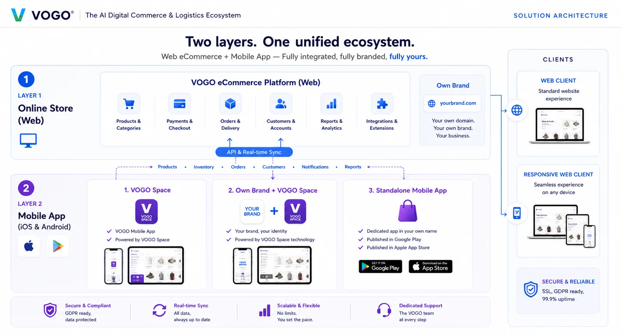

Modular architecture. Documented API. Optional On-Prem.
You get an enterprise platform with a layered architecture (Web, Mobile, API, Data), a mature stack (PHP/MySQL/Cloud), and native integrations with ERP, CRM, marketplaces, and BI.
- Layered architecture: Online Store (Web) + Mobile App (iOS/Android) + API & Real-time Sync
- Stack: PHP, MySQL, Redis, REST API documented in OpenAPI, configurable webhooks
- Flexible deployment: SaaS (AWS, Azure, GCP) OR On-Premise on your own infrastructure
- Security: JWT Secure, GDPR, SSL/TLS, 2FA, OTP, full audit log, end-to-end encryption
- Native integrations: ERP (SAGA, SmartBill, SAP, Microsoft Dynamics, Oracle), CRM, payments, courier
- 99.9% uptime SLA, 24/7 monitoring, dedicated technical support
5. Mobile Application — VOGO MAF (Mobile Application Framework)
VOGO eBS includes native iOS and Android mobile applications for customers, partners, and external users, connected to the same ecosystem.
▸ Lets users access all relevant features from the portal directly on the mobile device  ▸ Fully responsive design, automatically adapted to phone and tablet screen sizes  ▸ Supports offline work: data entry and events stored locally on the device, with automatic sync on reconnect  ▸ Sends push notifications to the user on any change or progress in their requests  ▸ All communication is over secure channels (SSL/TLS) between device and servers  ▸ Supports login / register with: Google, Apple, LinkedIn, Facebook, Microsoft, Email; OTP via SMS, Email, and Authenticator app.  ▸ Lets users review their profile and start requests even in offline mode. Detects offline mode and informs the user.  ▸ Supports handwritten digital signatures directly on the device's touch screen  ▸ Generates and sends signed PDFs directly via email from the app  ▸ Generates and submits orders directly from the app  ▸ Enables rapid development of custom/tailored apps, with assistance and pre-check for publishing in Google Play and the App Store | 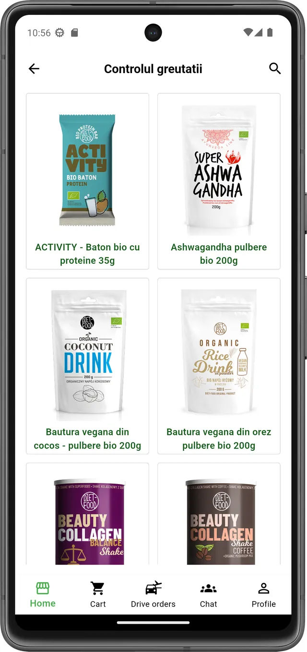  Responsive design — mobile view
6. Security & GDPR Compliance
- Robust authentication and authorization with differentiated profiles
- Encrypts all communication between user and servers via SSL/TLS
- Stores personal and commercial data securely, with periodic audits and advanced monitoring
- Fully compliant with GDPR requirements for personal data protection
- Full audit log of every action on the platform
- JWT Secure — full authentication and token management for all channels
- GDPR & SSL/TLS — compliance with EU data protection regulations, end-to-end encryption
- 2FA & OTP via email — two-step verification for users and administrators
- Social Login — Facebook, Google, Apple with a single click
- Full audit log — every action on the platform is recorded and available for audit
- 99.9% uptime SLA — scalable, redundant infrastructure, 24/7 monitoring
- AI-Powered Smart Automation — fraud detection, transaction scoring, real-time alerting
- White-Label EU-Registered — your own brand, data stays with the customer, no vendor lock-in
- Integrates ROeID and eIDAS for verified digital identity at national and European level

7. Supported Integrations

VOGO® eBS eCommerce integrates natively with a wide ecosystem of services — from payments and courier to ERP, CRM, marketing, and BI — so customers can extend the platform without changing their existing flows.

 | 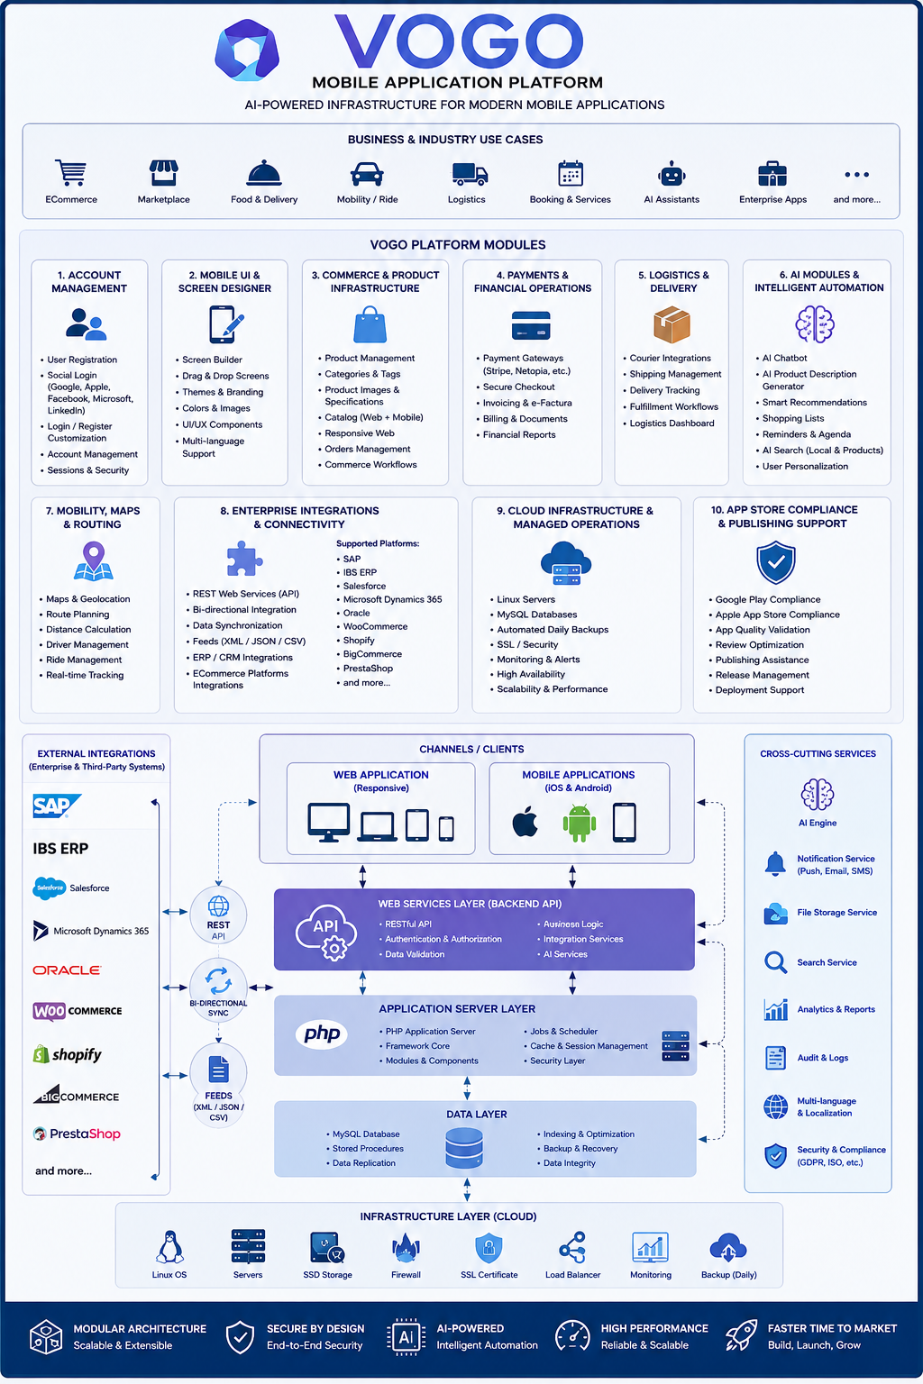
  ROeID | Digital identity for individuals, form pre-fill, masked national ID
  eIDAS | Electronic identity recognition at European level
  Invoicing system | Automatic invoice issuance
  GIS Module | Interactive map field in forms, address geocoding, request localization
  Stock management | Automatic stock management
  AI Chatbot | Live assistant 24/7, HITL, form-filling guidance, multi-channel support
  Email / SMS | Automatic status notifications, signed PDF delivery, confirmations
  Payments system | System for national and international payments, authorized payment processors
  Deliveries | Delivery system, automatic AWB issuance, order status updates
  Push messages | In-app and mobile push notifications
  ERP systems | Oracle, SAP, Microsoft D365, Odoo, Sage, Epicor

8. Key capabilities — Commerce, Logistics & AI
Catalog & buying experience
- Visual categories with custom photo icons, fast global search by name, description, tags
- Product page: hero image, rating with reviews, price, quantity selector, description, Add to Cart
- 7 action icons on the product page: Back, Live View, Video call, Live chat, Wishlist, Recommend, Help
- Multi-vendor cart: products from different vendors in the same cart, with automatic per-vendor shipping calculation
Orders, Drive Orders & Invoicing
- Full Order Details: General (date, status, customer), Billing, Shipping, product list
- Customer History: Total orders, Total revenue, Average order value, quick order actions
- Drive Orders — dedicated tab for delivery, taxi/transport, Mall Delivery, with approval flow and GPS tracking
- Automatic PDF invoicing — generated and sent by email upon order confirmation
- Multiple payment methods: Cash on Delivery, card (Stripe, Netopia, EuPlătesc, PayU), Apple Pay, Google Pay

Push, Live Chat & Assisted Sales
- Text scroll banner — scrolling text at the top of the app (60–80 characters)
- Full push message — text up to 300 characters, optional image, delivery status, run delivery job
- Live chat with a sales consultant on every product, operator responds from the Brand Control Center
- Product Live View — live streaming of the product directly in the app
- 1-on-1 video call with a consultant for pre-purchase advice
- Recommend — peer-to-peer mechanism for validating vendors and products
AI & Smart Automation
- Personalized product recommendations based on customer history and behavior
- Conversational AI assistant 24/7 with Human-in-the-Loop (HITL) mode — hands off to a human operator when needed
- Real-time fraud detection on transactions and suspicious behavior
- Customer scoring and automatic segmentation for targeted campaigns
- Dynamic price optimization and predictive stock management
9. Integrations & Interoperability
VOGO® eBS eCommerce Suite integrates natively with a wide ecosystem of services — from payments and courier to ERP, CRM, marketing, and BI — so customers can extend the platform without changing their existing business flows.
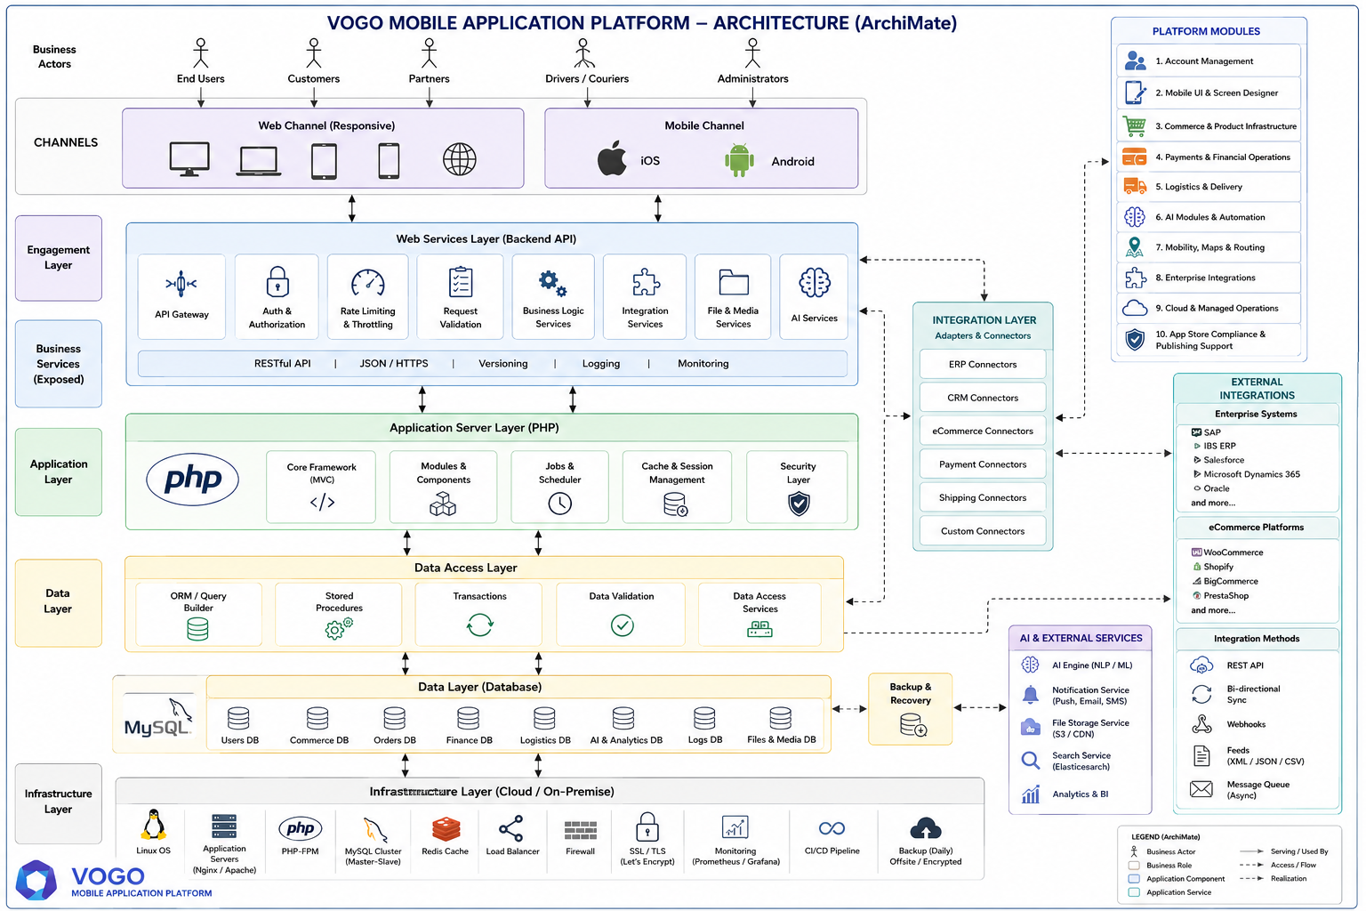
Web + Mobile Sync | Bidirectional real-time sync via API: products, stock, orders, customers, notifications.
Online payments | Stripe, Netopia, EuPlătesc, PayU, Apple Pay, Google Pay, Cash on Delivery — PSD2 and 3DS compliant.
Courier & Logistics | Integrations with courier companies, Drive Orders with GPS, order tracking, Mall Delivery.
Invoicing & ERP | Automatic PDF generation, integration with ERP/accounting systems (SAGA, SmartBill, Oblio, SAP).
Marketing & CRM | Push notifications, advanced segmentation, email/SMS, WhatsApp, loyalty and referral programs.
AI & Support | Live chat with HITL, smart recommendations, fraud detection, product video call, Live View.
Digital identity | Social Login (Google, Apple, Facebook), OTP email, 2FA, JWT Secure, GDPR compliant.
Analytics & BI | Sales reports, user behavior, conversions, configurable dashboards.
Industries & common applications
- Manufacturing / Producers – product promotion and sales
- Professional associations – promotion and member support
- HoReCa — Food & Delivery — Healthy Market, restaurants, orders and delivery via Drive Orders
- Chambers of Commerce & Professional Associations — corporate website and catalog of member services, portal for business interaction, online store for promotional products or licenses, dedicated mobile app
- Federations & Agricultural Cooperatives — collective ordering platform, distribution network management, member portal with negotiated pricing, mobile app for field data collection
- Retail Networks & Franchises — multi-vendor or multi-brand online store, B2B portal for distributors, white-label mobile app per franchise
- Maintenance & Services Associations — online bookings, ticketing for interventions, customer self-service portal, push notifications via mobile app
- Real Estate Associations & Building Administrators — fault reporting portal, online payments for shared services, document base for tenants, mobile app with notifications and request approvals
- Medical & Wellness Organizations — online appointments, patient portal, store for products or supplements, mobile app with loyalty and subscriptions
- Industry & Manufacturing — B2B catalog with contract pricing, order portal with approval flow, ERP integration, mobile app for sales reps
- NGOs & Non-Profit Organizations — corporate website and online donations, merch store, volunteer portal, mobile app for the community
- Education & Professional Training — course catalog and online enrollment, student portal with access to materials, mobile app for learning and certification
- Tourism — bookings, ticketing, local guides, mobile app with destination catalog
- Education — tutoring, online courses, in-app registration and payment
- Medical & Pharma — 24/7 pharmacies, consultation bookings, ophthalmology, nutrition products
- Health & Wellness — organic products, nutrition coaching, retreats and spa
- Pets — food, accessories, veterinary services with detailed profiles
- Coaching & Entertainment — coaching sessions, wellness retreats, cinema tickets, live broadcasting
- Transport & Local Services — products, services, transport, airport transfer, Drive Orders with GPS
- B2B & Associations — member services catalog, B2B portal with contract pricing
Benefits for B2B customers & Partners
VOGO® eBS eCommerce Suite is built for B2B enterprises, distributors, resellers, transporters, and influencers who want to launch or consolidate their digital presence without investing in their own development. The platform delivers measurable results in weeks, not months.
Time-to-Market  Fast launch  From kickoff to go-live in weeks, not months — configurable template, no code. | White-Label  Your own brand  iOS & Android app published under the customer's brand in the App Store and Google Play. | Unified  Web + Mobile  One backend, one catalog, one control center. Real-time sync.
AI-Powered  AI automation  Recommendations, fraud detection, HITL chat, customer scoring, and sales optimization. | SaaS / On-Prem  Flexibility  Cloud (AWS, Azure, GCP) or your own infrastructure — same code, full control. | GDPR  EU-Registered  GDPR compliant, SSL/TLS, JWT, 2FA, full audit log, 99.9% uptime SLA.

